Take a moment and browse through. There are some samples of poems, vows, ring blessing, prayers and closing prayers. I know, without a doubt, this is one of the most important days of your life. I love to work with you in creating the perfect ceremony for your special day. Peace….Michael
SAMPLE OPENING
Welcome family and friends. Today we have all gathered here together to witness and support in joyous celebration two extraordinary individuals, friends and lovers as they consciously choose to enter into one of the most loving and sacred commitments two people can choose to make foe each other and themselves.
(Address parents if present) Your children have been nurtured in and by your love. They have been guided wisely by your counsel. As they return to this recognition of oneness, in this ritual we call marriage; they would like to ask for your trust, assistance, and most of all your loving and affectionate blessings. (Address parents) Do you support and affirm their free choice to see themselves in and as each other every day they choose to be together? Do you offer them the best of your care and counsel in their times of struggle and your participation in times of celebration and joy even though you may not agree? (They answer)
We Do.
Please be seated

SAMPLE SERMON (if you will)
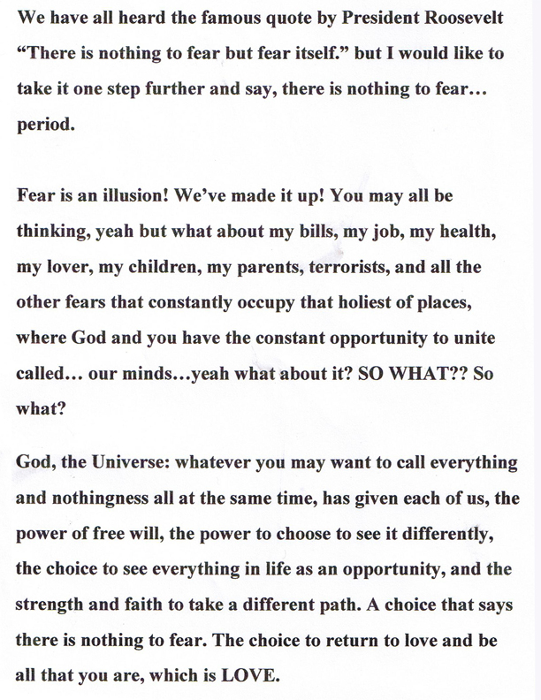
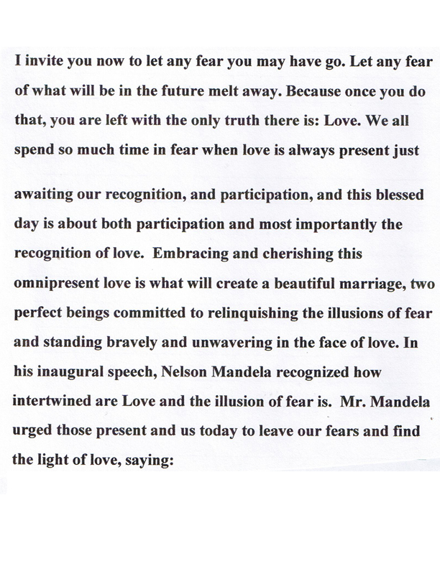

SAMPLE POEM
Our deepest fear is not that we are inadequate,
Our deepest fear is that we are powerful beyond measure.
It is our light not our darkness, that frightens us.
We ask ourselves who am I to be brilliant,
gorgeous, talented, and fabulous?
Actually who are you not to be?

You are a child of God.
Your playing small does not serve the world.
There’s nothing enlightened about shrinking
so that other people won’t feel insecure around you.

We were born to make manifest the glory of God
that is within us, it’s not just in some of us;
it’s in everyone.

And as we let our light shine, we unconsciously
give other people permission to do the same.
As we are liberated from our own fear,
our presence automatically liberates others.

Sample Poem
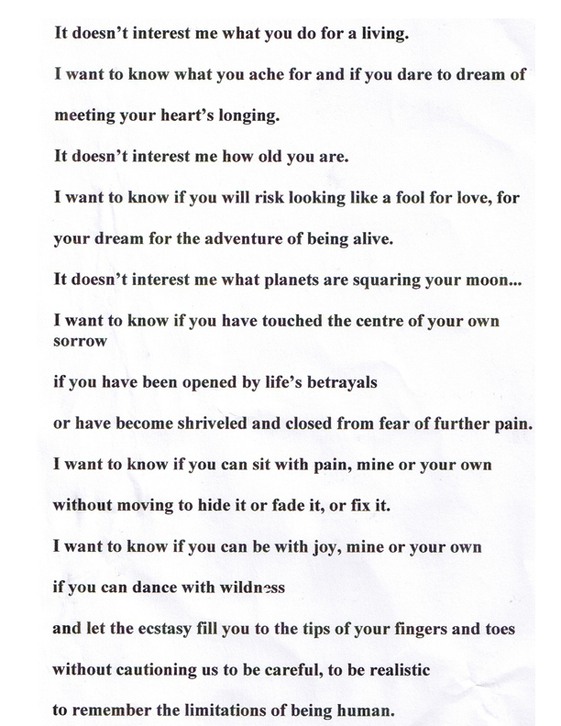
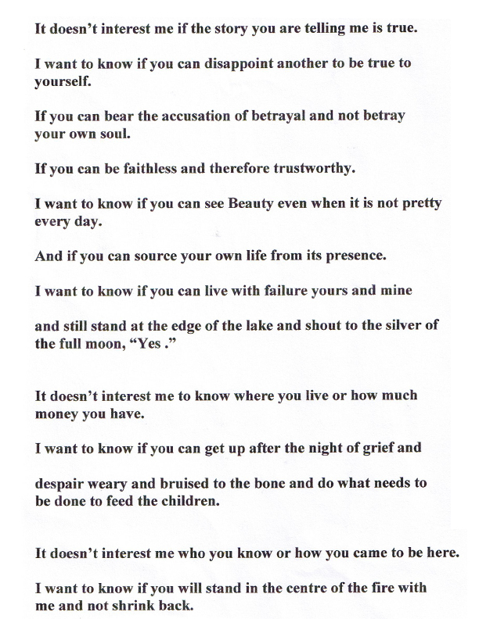
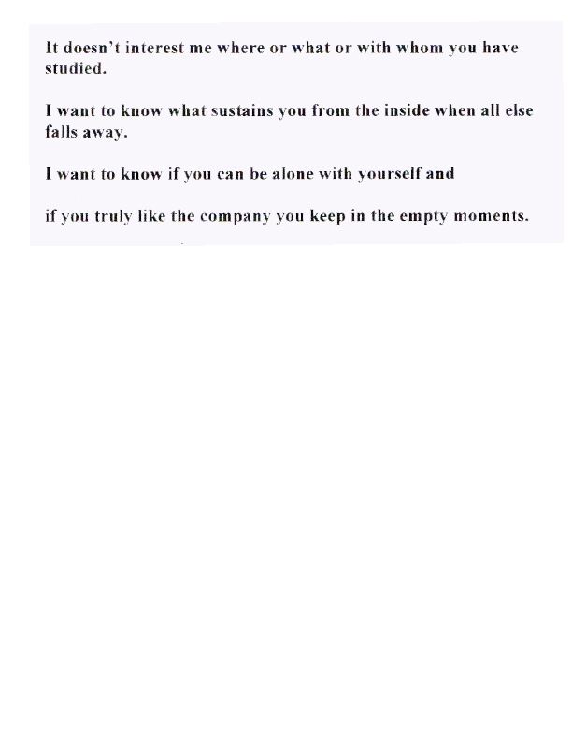
Sample Poem 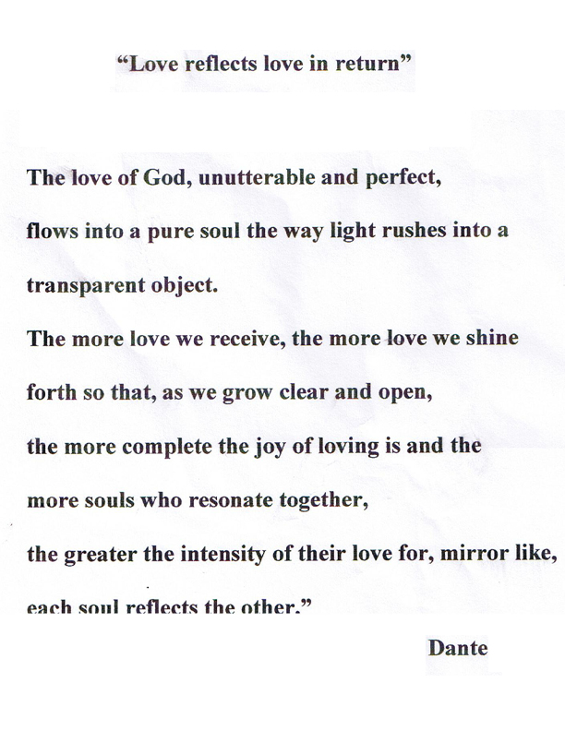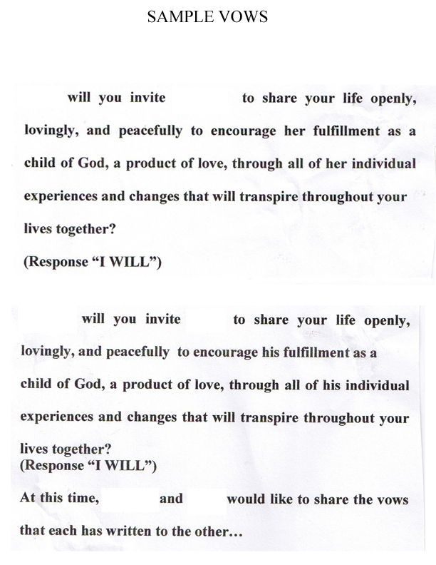
Sample ring blessing
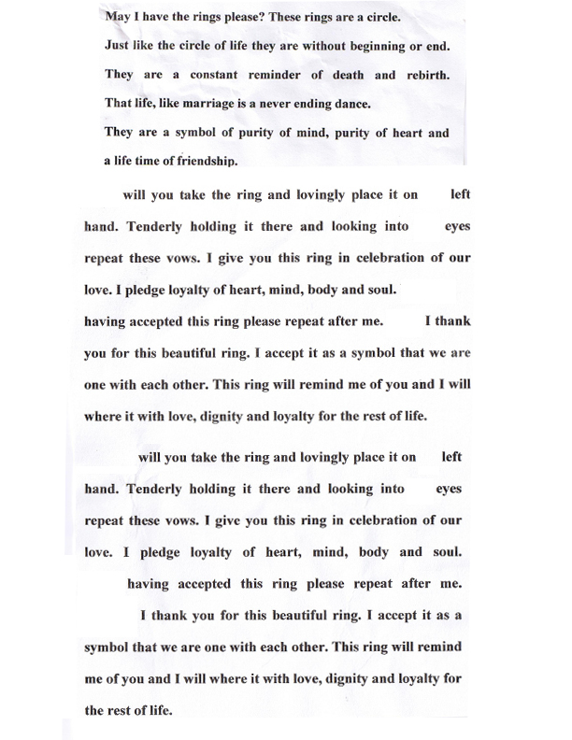

Sample Prayer
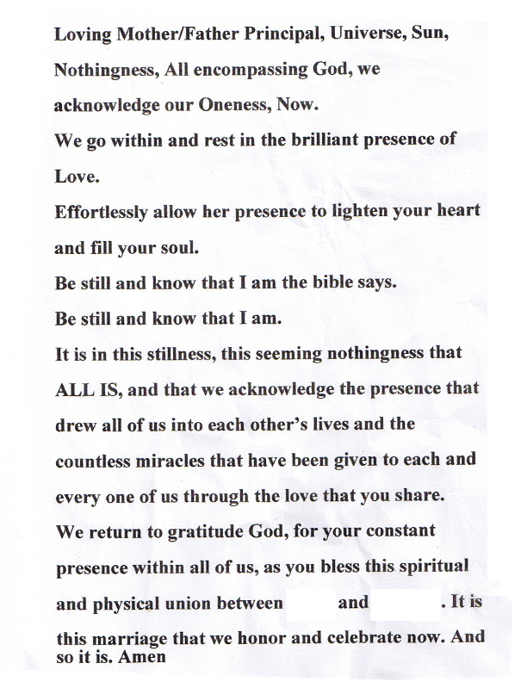

Sample Closing Prayer
