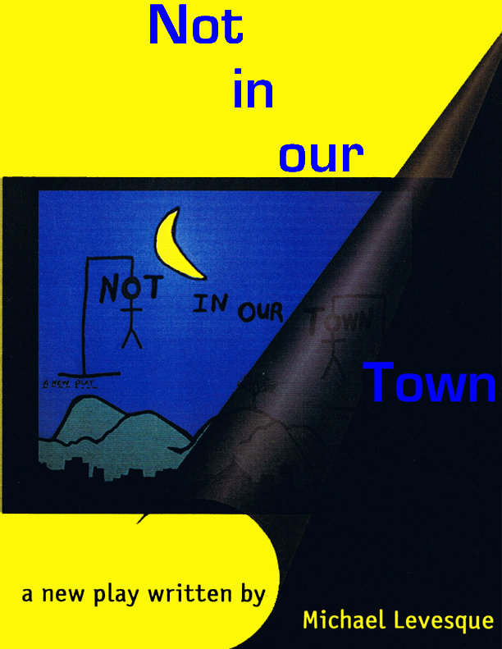
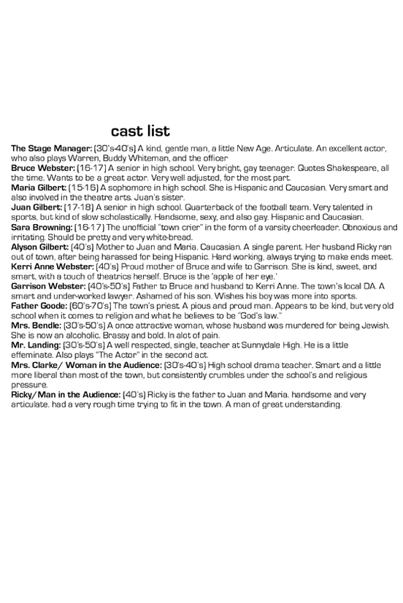
ACT ONE
(The stage is blank except two tables down stage one stage right and one stage left both with chairs around them. There are two ladders up stage representing the two story homes. The back scrim should have mountains on it and the silhouette of a great mighty oak. You should be able to have sunrise, sunset and evening all on this backdrop. The play opens. The stage manager is already on stage as the last of the audience is still taking their seats. Once everyone is seated the cast members enter one at a time. They take the positions that will also end the first act. At this point they are just looking very casually at the audience. The stage manager comes center and motions for the cast to move. They do. Next, he starts with deliberately putting a base ball cap on. This should be obvious that he is now assuming a role.)

STAGE MANAGER(as Warren)
Can I now have Bruce William Webster reading the role of George,(a young man of 17 enters through the house and climbs on stage) and Maria Gilbert, reading the role of Emily. (a young girl of about 15 does the same) Please turn to page thirty nine. (they do) This is the scene right before the wedding.
BRUCE
(he grabs Maria’s hand) “Now join your hands and with your hands your hearts.”

STAGE MANAGER(as Warren)
(Searching through his script) What?? Where are you??......That’s not in here.....
BRUCE
Of course it’s not. It’s the third part of Henry the Sixth.
STAGE MANAGER(as Warren)
Bruce! This is not Shakespeare! This is Thorton Wilder. Come on, get with the program.
BRUCE
Sorry Warren .....
MARIA
I thought it was nice. I liked it.

BRUCE
Thanks.
STAGE MANAGER(as Warren)
Now, as I was saying. This is your wedding....you’re young, inexperienced,....We want to see you nervous and frightened. Filled with fear....
BRUCE
“Let pale faced fear keep with the mean-born man, and find no harbour in a royal heart.”

STAGE MANAGER(as Warren)
Bruce, come on. Not only are you wasting our time, but no one knows what the heck you’re talking about.
MARIA
I do.
BRUCE
I can’t help myself...besides, it assists me with getting into character.

MARIA
You were saying....young, inexperienced....
STAGE MANAGER(as Warren)
Yes! Absolutely! This is probably the first time either of you have ever even kissed someone else. All right?

BOTH
Yes...
STAGE MANAGER(as Warren)
Any questions?

BOTH
No....

STAGE MANAGER(as Warren)
Are you ready?
BRUCE
Yes! “The actors are at hand and by their show you shall know all you are like to know.”
STAGE MANAGER(as Warren)
A simple yes or no would do Bruce.
BRUCE
Yes...
STAGE MANAGER(as Warren)
Maria?

MARIA
Sure....
STAGE MANAGER
Then begin...(the stage manager steps out and takes off his baseball cap, as they continue in pantomime silence. the house light finally dim as he begins) This play is called “NOT IN OUR TOWN.” It was written by Michael Levesque. Produced by(the name of producers), and directed by.........(their name) In it you will see Miss........, and Miss...., and Mr......., and many others. The name and location of this town are unimportant. It’s not the town in and of it self that is unimportant. No, on the contrary. It’s just we don’t need another name, another title, another border, another attempt to separate what is in truth inseparable. Whoa... I am getting way ahead of myself. Besides, many people in this town don’t particularly like my personal views on time, space, my belief in oneness and unconditional love, and trust me on this, when people in this town don’t like your point of view, they let you know, one way or another.(Mrs. Bendle enters)
MRS. BENDLE
You can say that again..

STAGE MANAGER
Mrs. Bendle, we're not ready for you yet. That wasn’t your cue.
MRS. BENDLE
What ever.....(exits)

STAGE MANAGER
Most people in this town prefer it if you would just remain silent with no personal view whatsoever. It makes them feel safer and more secure. It soothes their fears.(Bruce breaks the pantomime and steps down stage)
BRUCE
“Of all base passions, fear is most accursed.”

STAGE MANAGER
Thank you Bruce, but I think Maria needs you back at the audition. Now...
BRUCE
“More I could tell you, but more I dare not say, The text is old the orator to green.”
STAGE MANAGER
Alright! Enough with the Shakespeare...GO!! BEGONE!!(he returns to the scene with Maria) Gee’s where was I?

BRUCE
Fears!
STAGE MANAGER
Right! Fears! It soothes their fears. I guess that’s why the middle class is so addicted to television, it doesn’t really effect them, God forbid, as much as soothes them. So anyone who in the least bit threatens that, is quite often referred to as a rebel, or sinner or in my personal case, a hippy. Hippy? Hello, get with the times.(Sara steps out and does a cheer)
SARA
H.I.P.P.Y. Hippy, hippy, yeah hippy!

STAGE MANAGER
Sara, it’s not your time yet. Don’t you have more make up to put on? Or more hair spray to spray or something?
SARA
Geek!(she exits)
STAGE MANAGER
That was Sara, the town crier in the form of a Varsity cheer leader. Whew... I really got off the track there. The first act of our play will show you a couple of weeks in our town. The time now is early morning, just before the chorus of alarm clocks will sound, the starting gun for the beginning of another new day. The year is now. The day today. Actually none of that really means anything either. There all just illusions aren’t they? You know, time, days, hours, years, I mean we made it all up! Like that lovely scene going on up there. That audition is what’s going to happen in about six hours from now. We still have to wake up first, get dressed, go to school, then go to the audition. Thank you two. You can go now.

MARIA
Thanks. That took forever. I still have to get ready for this. I have to do my hair and make up...

STAGE MANAGER
I know. I know. Go. Go get ready to wake up.

BRUCE
“If you can look into the seeds of time, and say which grain will grow and which will not, speak then to me, who neither beg nor fear your favors nor your hate.”

STAGE MANAGER
What??
BRUCE
Shakespeare. It’s from the Scottish Tragedy. It’s about time. You were just talking about time....

STAGE MANAGER
Right..... well then speaking of time, save it for LATER all right? Besides, don’t you need to get ready as well.

BRUCE
Affirmative! “Once more unto the breech dear friend once more.” (he charges off)
STAGE MANAGER
Actors...such show offs. Where was I? Oh... time! Vertical, not horizontal. Up and down not linear. Past, present, future is all happening right now, simultaneously. In fact, you’ve already all seen this play.

MR. LANDING(enters)
Then let them go home if they’ve already seen it. You’re wasting their precious time.

STAGE MANAGER
Mr. Landing, don’t you have a suit case to pack?
MR. LANDING
Not until the end of the first act, I still have TIME, thank you very much, but I get your subtle hint. (exits)
STAGE MANAGER
Thank you Mr. landing. (laughs) Oh, I can see from the blank expressions on your faces, and the constant checking of the watches as you’re flipping through your programs, trying to figure out who this actor is, that has already managed to lose you, that you’re probably going to like our town. You’ll fit right in.
FATHER GOODE(enters)
Well you're boring them to tears. Why don’t you leave the preaching to me? At least I stick to the holy scriptures and I’m also much better at it then you are.

STAGE MANAGER
I’ll remember that father Goode. Oh and Father Goode, what is that saying to be humble is to be holy, Is that it?

FATHER GOODE
Hippy Heathen!(exits)

STAGE MANAGER
Oh......look its definitely morning now. Beautiful, isn’t it? Breath taking. My favorite view in our little town is that right there, the sun rising over the tops of those gorgeous hills and the silhouette of that great big, powerful, mighty oak. Right on top of that hill, probably our proudest possession here in Sunnydale. I think we somehow intuitively relate to the deep roots, its strength and its longevity. Every year we see that mighty oak go through death, birth and death again. It’s a constant reminder of the cycle of life. You know? Besides it smack dead in the middle of the towns only grave yard. Which I personally think is kind of cool, you know, such great life in the midst of all that death. I’m lucky, I guess, I get to see this view every morning. I get up early to do my morning ritual, my yoga, and then my meditation. Funny, they think I’m some kind of commie Satanist or something. Don’t get me wrong, they’re a kind group of people, but full of fears. Fearful of anything different or any thing they don’t understand. You know, right?(to audience)Just like some of you are, right? So you know what I mean. I mean most of us are all afraid of something right? Just like all the other millions of people in this country. Speaking of fear, the popular religion here is some form of Christianity, Methodist, Protestant or Catholic.

FATHER GOODE
What’s wrong with that you commie Satanist?
STAGE MANAGER
Nothing is wrong with it. But why do they all have different names? Like titles or labels? It’s just another attempt at separation again. I just don’t get it.
FATHER GOODE
You’re right you don’t.

MRS. BENDLE
What about the Jewish faith? HUH? Hath not a Jew eyes... and ...um...arms..if you ..do we not...bleed.... you PRICK..us..if..(Bruce runs on)
BRUCE
Madam Bendle, please leave the Shakespeare to me...Please!(he exits)

MRS. BENDLE
Fine with me, I was only asking about the Jewish faith.

FATHER GOODE
What about it? You people killed our king.
MRS. BENDLE
Wrong! You people killed my husband!

STAGE MANAGER
Hey, both of you wait until it’s your cue or I’ll be forced to replace you.(they exit) Anyway....I guess I better finish setting up our little town for you. Well actually there’s not a whole heck of a lot to set up, the local hardware store, grocery market, hospital where most of us in this town were born. You see not too many people move here. Most of us were born here and remain here. It’s safe that way. There’s a couple new strip malls, and we even have a fast food restaurant. Just between you and me, it’s not like the city, there’s absolutely nothing fast about this food except maybe the rate of speed it leaves your body, if you catch my drift. We have a movie theatre, town hall, court house, library, and a couple of dozen track homes. Take this one over here. This one over here belongs to...oh...there I go again, my old conditioning.
Belongs to? Does anything ever really belong to any one. Our spouse, homes or even our bodies? I prefer to think of it now as stewardship. We are the stewards of our homes, this land, or our bodies. Nice thought isn’t it? I think so. So, having said that, the steward of this home is one of this towns most prominent citizens, our local criminal lawyer, and D.A. Mr. Garrison Webster. I probably don’t have to tell you he’s not the busiest man in town, though he did handle Mrs. Bendle’s case, until it was thrown out for lack of evidence. He occupies this dwelling with his, I mean, with “A” lovely and caring wife Kerri Anne and their....I mean... “A” son, Bruce. Bruce was the young man we saw up there earlier chewing the scenery. He is a promising young man with a bundle of talent, creativity, and more knowledge of the Bard then anyone you’ll ever meet, ahead of his time for this town. I suspect he’ll go far, that one. Over here, we have the stewards to this dwelling, Mrs. Alyson Gilbert, a single mother living here with two children, Maria and an older brother Juan. Maria was the young girl trying to find any left overs of the scenery from Bruce earlier. Juan is something of a local star himself around here. He’s the greatest quarterback Sunnydale high school has ever known, and quite a looker.(Sara enters)

SARA
You can say that again!
STAGE MANAGER 7
That wasn’t your cue Sara, I said looker not ....

SARA
Hey!! Watch it geek!!(she exits)

STAGE MANAGER
The Gilbert family has overcome a lot of hardships. You see I would love to tell you that Alyson’s husband died of some incurable terminal disease and that he’s buried up there under that mighty oak, but that would be a lie. The truth is no one really knows what happened, he just got up and left one day. Maybe the time finally came when he just couldn’t take it any more, the teasing and gossiping. It was really awful for awhile. Luckily Alyson was able to ride it all out, and in time put her life back together. An amazing woman she is, strong just like that oak. You see this town had never really seen a Hispanic man before, so when Alyson came back from college to take care of her ailing parents with a Mexican boyfriend, well....it wasn’t easy. Eventually the parents passed and Alyson and Eduardo married and took over stewardship of this here home. The town was relentless at first calling him Enchilada Eddie....they stuck it out and gave birth to Juan and Maria. The first two half breeds this town has ever seen. That’s what they called them, not me. I think it just got to poor old Eddie and he had to leave. Poor kids, never got to know their father.(Mrs. Bendle enters)
MRS. BENDLE
What about my pain, my grief huh? What about that?
STAGE MANAGER
Like it or not Mrs. Bendle you are only a minor character in this play.

MRS. BENDLE
ANTI SEMITE!(exits)
STAGE MANAGER
Right before Eddie left town, he did an amazing thing. He went to our local banker and resident Jew, the late Mr. Barry Bendle and took out a loan and opened a little restaurant in our first strip mall called Enchilada’s Eddies. Then he took off. Some think that may have been his way to help set up his family’s security. Unfortunately it didn’t work, the restaurant folded and Mr. Bendle took it over and tried to open a Bendle’s Bagels. No one here even knew what a bagel was then. It folded too, right after Mr. Bendle was found dead near the bank's night deposit. Oh yes, it is indeed morning. The first tell tale sign, Mrs. Bendle, trying to hide her bottles wrapped in brown paper bags in the Webster’s garbage. Poor thing ever since the death....

MRS. BENDLE
MURDER!

STAGE MANAGER
....Death of her husband, she’s taken a liking to the bottle. It was never proven, some say it was a murder some say a freak accident.

MRS. BENDLE
The only freak accident in this town is Sara Browning.(Sara enters)
SARA
Hey!! I heard that.
MRS. BENDLE
Good!

SARA
You old drunk.(exits)

STAGE MANAGER
Morning, Mrs. Bendle. (whispers) That’s your cue.....

MRS. BENDLE
Oh....Morning darling, you’re up early.
STAGE MANAGER
Yes ma’am I am.

MRS. BENDLE
Well, have a good day.(exits)

STAGE MANAGER
You too. You see the thing about this town is, even if there was a murder or infidelity or anything really horrible, they’ll all talk about it but no one(during this Mrs. Bendle has quietly sneaked on stage to the stage manager) May I help you?
MRS. BENDLE
How was I? Did I do all right?
STAGE MANAGER
You were great. Now go till your next cue.(she exits) They’ll talk about it but they will never admit that anything remotely hateful or raciest ever goes on here. You point blank ask them and every single one of them will say "no way, not in our town."(the alarm clocks go off) Well, that was it, that chorus line of alarm clocks. The time is here, another day begins.(The two families enter and start their days. Alyson is cooking breakfast. Juan and Maria are on one ladder and Bruce is on the other ladder. Alyson enters and starts breakfast too. Juan is pounding on the ladder like it’s a door.)
ALYSON
(calling) Juan, Maria...breakfast!
MARIA
Coming mom. Juan!!
JUAN
What?

MARIA
I was here first.
ALYSON
Come on you two, don’t fight over the bathroom.

JUAN
She always gets it first.

MARIA
Because I’m faster than you are.

JUAN
No, you just need more time to try to make yourself look good.

ALYSON
Juan!!

MARIA
Mom!
ALYSON
He’s only joking Maria. Aren’t you Juan? Juan!
JUAN
.(entering) Yeah....
ALYSON
Don’t be mean to your sister Juan, she’s the only one you got.
JUAN
I know Mom.
ALYSON
Be a dear and get me my news paper.(he goes to what would be a door and opens it. Sara passes by)

SARA
(flirting) Morning, Juan.
JUAN
Morning, Sara.
SARA
Are you going to win the game for us Friday night?

JUAN
We’ll see.
SARA
I hope so.

JUAN
Me too. Bye. (returns to the house)
SARA
(calling) I’m on my way to practice right now. We’re learning all new cheers for the big game.
STAGE MANAGER
I don’t think he really cares Sara.
SARA
Who’s talking to you geek? I certainly wasn’t.(she starts to exit)

STAGE MANAGER
That’s our Sara, the towns...
SARA
Hey!

STAGE MANAGER
...Cheerleader.

SARA
(cheers) S.u.n.n.y.d.a.l.e. Sunnydale, Sunnydale, yeah Sunnydale.(runs off)
STAGE MANAGER
Inspiring isn’t she?(Maria enters)

MARIA
Mother, we’re out of shampoo.
ALYSON
Oh honey ...I’m so sorry... I forgot....I’ll get some today...
MARIA
Well, that doesn’t help me right now, does it?
JUAN
Hey, that’s your mother you're talking to like that.

MARIA
Oh mind your own business jock strap. MOM!

ALYSON
What?
MARIA
My hair.....
ALYSON
Use the bar soap.
MARIA
Mom...
ALYSON
What Maria?(Juan shoots Maria a look)

MARIA
(Pause) Nothing..... I just wanted to look good for my audition today.
ALYSON
Oh Maria...the audition. I’m sorry sweetheart.

MARIA
You’re always sorry.

JUAN
Hey!! Maria!!!
MARIA
Hey yourself! This is important to me alright?(she sits to eat)

JUAN
Mom, why do let her talk to you like that?

ALYSON
Please.....Why do I let her? You kids are really too much, you know that? She’s right. I should have gotten the soap. I just forgot. Breakfast?(they pantomime grace then they start breakfast.)

KERRI
Bruce honey, breakfast is ready.(Garrison enters) Good morning sweetheart.
GARRISON
Good morning dear.(she follows him with coffee)

KERRI
Bruce, come on honey, you have to eat.
BRUCE(off)
I’m coming....
KERRI
(calling)BREAKFAST!!

BRUCE
(calling) “I will bestow a breakfast to make you friends”

GARRISON
Does he ever stop with the quotes?
KERRI
(calling) BRUCE!!
GARRISON
(reading the paper)Let him be, he’ll come down when he’s good and ready.
KERRI
I just don’t want him missing breakfast all right?
GARRISON
Just relax mother.
KERRI
Sometimes I think you just don’t want your own son around you Garrison.
GARRISON
Now what kind of talk is that Kerri Anne? That’s ridiculous.

KERRI
Is it?
GARRISON
Yes MOTHER......
KERRI
oooh....Why do you do that to me?

GARRISON
Why do I do what?
KERRI
Always refer to me as Mother.
GARRISON
I don’t always refer to you as mother.
KERRI
Yes, actually you do.

GARRISON
No, actually I do not. Why only two minutes ago I believe I called you dear. I rest my case.

KERRI
You know what I mean.
GARRISON
No, I know what you say....(he laughs)
KERRI
Oh just forget it...
STAGE MANAGER
Excuse me just for a second. You’re both doing great.

