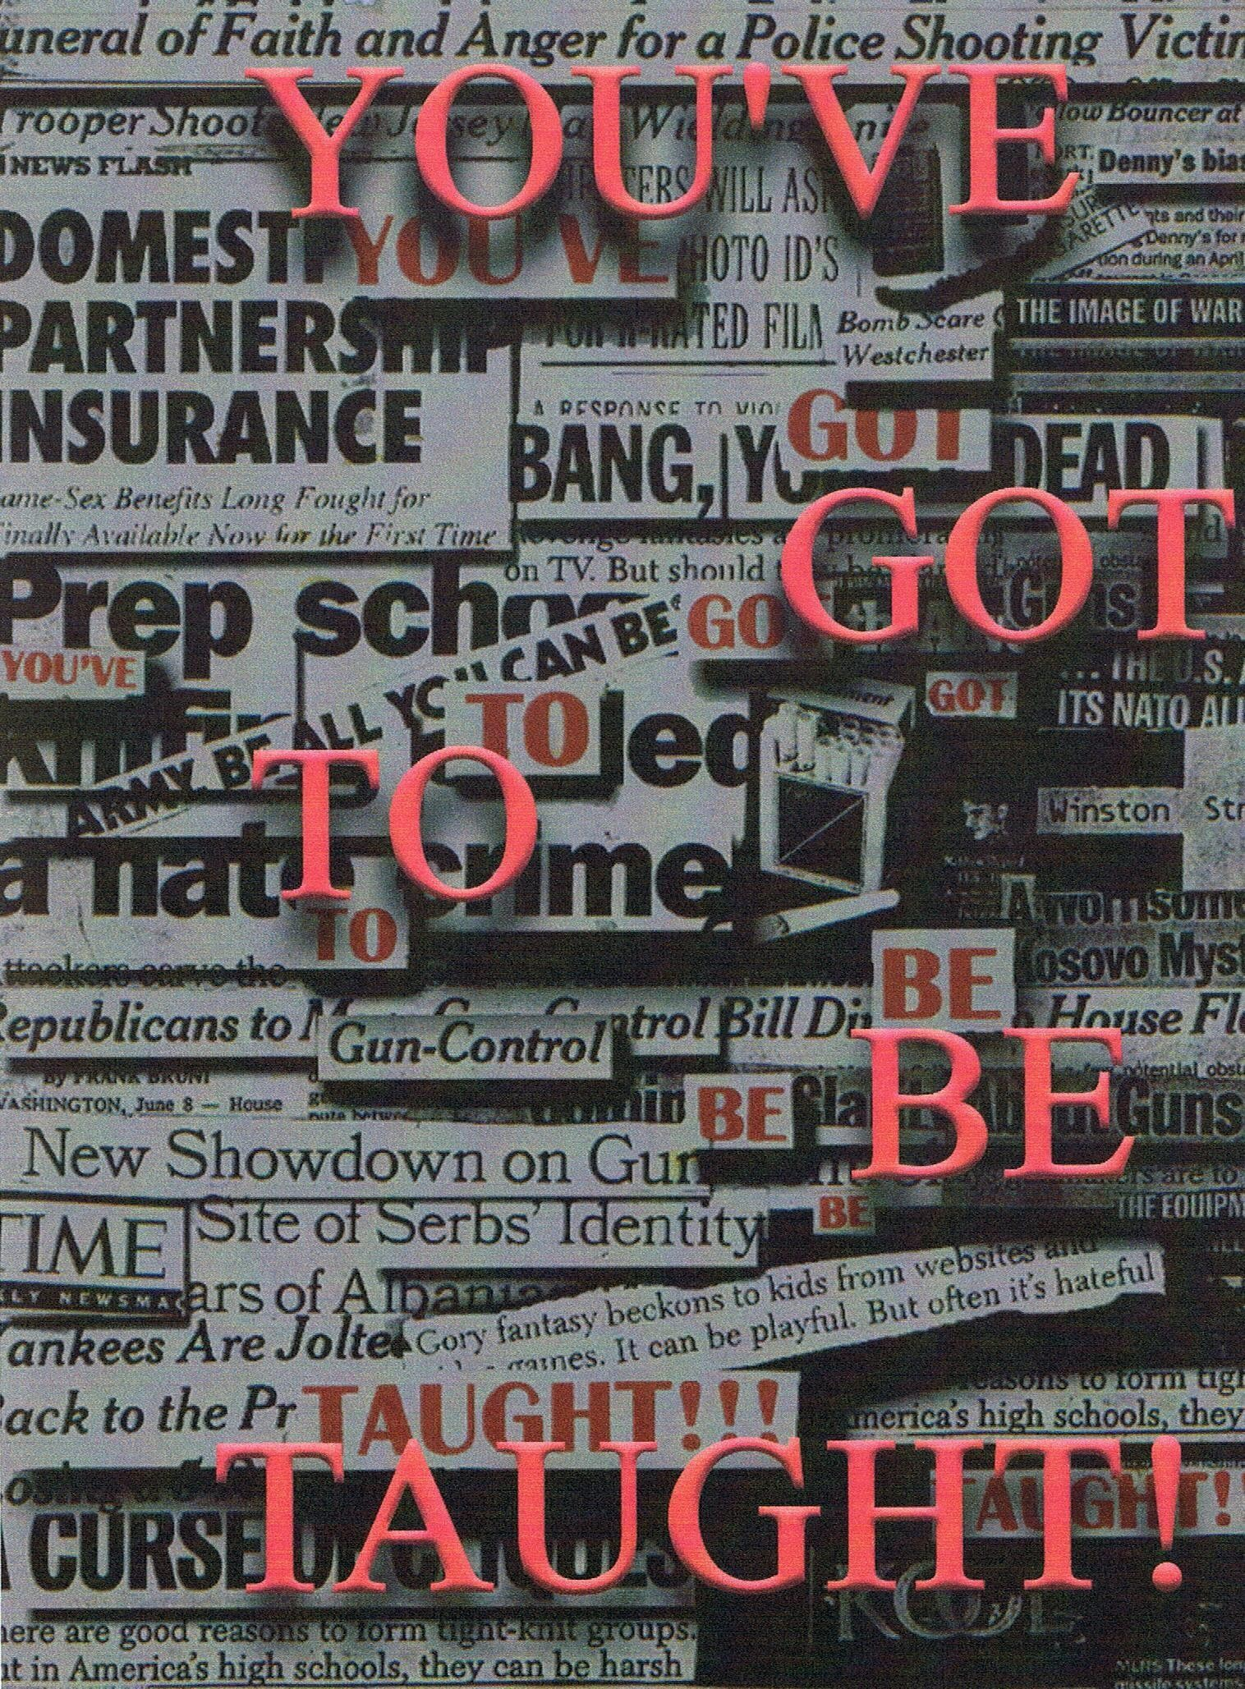
All Rights Reserved
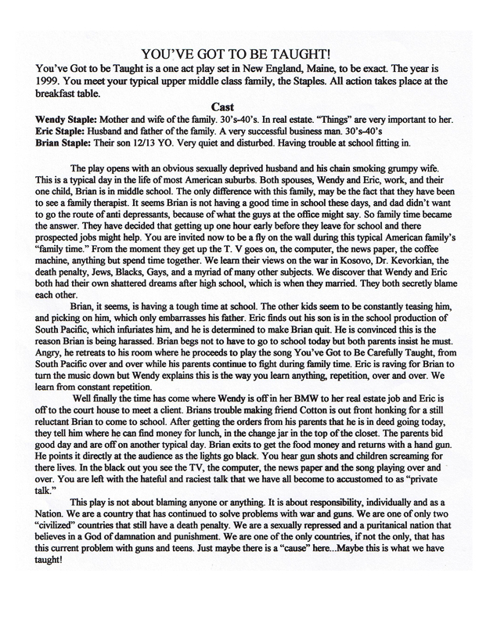
Sample Scene

ERIC
BRIAN!!

WENDY
ERIC!!

ERIC
Wendy please, I’ll handle this. Brian answer me.

BRIAN
Umm…umm… Co…Cot... Cotton....

ERIC
GOD DAMN IT!!

WENDY
Eric, stay calm.

ERIC
Wendy, don’t tell me to stay calm. I’ll handle this.

WENDY
No, you will not handle this if you can’t stay calm! This is exactly what we’re not supposed to be doing!

ERIC
Brian, come here. What did I tell you about Cotton7 God damn it!!

WENDY
God damn it Eric, don’t yell at him!

ERIC
Wendy, sit down!

WENDY
Don’t tell me to sit down.
ERIC
You’re getting hysterical.

WENDY
Because you’re yelling at him! Brian, sweetheart, we care about you dear. You know that right? BRIAN!!

BRIAN
Yes!

ERIC
I told you I didn’t want you hanging around Cotton anymore.

BRIAN
Why?

WENDY
Because he’s trouble dear.

ERIC
The kid got caught stealing a VCR out of his neighbor’s home. Now come on sport.

BRIAN
But...but… (he cries)

ERIC
Brian... BRIAN! Oh Jesus, he’s crying now. What the hell is he crying about?

WENDY
ERIC!

ERIC
He’s sixteen years old. He shouldn’t be crying.

WENDY
(she goes to him) Brian...Brain honey...

ERIC
Don’t encourage this Wendy.

WENDY
You be quiet! Brian…Brian?

BRIAN
What?

WENDY
Hey, what are you crying about sweetheart? Talk to us.

BRIAN
Cotton’s my friend....
ERIC
No son, Cotton’s trouble. Kid’s like him prey on kids like you. They know you’ll do anything, they know you’re just...

WENDY
Eric! Let me, please. Please!

ERIC
He’s my son too! You expect me to just sit here and allow this?

WENDY
Yes, we’re taking care of it. Now be a dear and get me some aspirin. Now Brian... Brian??

BRIAN
What?

WENDY
You can ride with Cotton today all right?

BRIAN
I can??

ERIC
WENDY!

WENDY
Aspirin, Eric! Yes, but you have to tell him today that this is it, no more after today alright?

BRIAN
But.,.but..

ERIC
No butts Brian, your mother is right.

WENDY
ERIC, aspirin! Is that a deal?

BRIAN
Fine, but then who the fuck is going to stick up for me now huh? Tell me that!! Cotton’s my only God damn friend!! (he runs out)

ERIC
BRIAN!!!

WENDY
Let him go...

ERIC
Let him go? What the hell was that about? Huh? “Stick up for him?” What the hell is he talking about?

WENDY
Did you find my aspirin?
ERIC
Wendy, I’m asking you a question.

WENDY
Eric I am well aware of that but now I’m asking you one. Did you find my aspirin?

ERIC
No, I didn’t. Wendy, tell me what’s going on.

WENDY
Wait! Light me a cigarette. I’ll get my own aspirin. (he does and she gets the aspirin)

ERIC
Here. (hands her cigarette)

WENDY
I’ll trade you. See if you can get the damn thing open. They child proof everything these days and I just don’t have the patience.

ERIC
Wendy, what is Brian talking about? Protect him? (you hear the song “You’ve Got to be Carefully Taught playing from Brian’s room) Why is he playing that music? Wendy? WENDY!!

WENDY
What??

ERIC
I’m asking you a question.

WENDY
Would you just give me a second? How are you coming with my aspirin?

ERIC
I can’t get it open.

WENDY
Here give it back. Brian has been having some trouble at school.

ERIC
Like what? I thought his grades were great.

WENDY
His grades are not the problem. Now promise me you’ll stay calm.

ERIC
Wendy!!

WENDY
ERIC...

ERIC
Alright I’m calm. Why is he playing this God damn music?
WENDY
Calm is the key word here Eric, calm. Well, a couple of the guys at school have been picking on him.
ERIC
What?? BRIAN!!

WENDY
Eric, so help me
-
ERIC
You’re right...sorry. Who? Wendy, do you know who?

WENDY
Damn it, I can’t get these open. Hand me my coffee dear.
ERIC
Wendy...

WENDY
Oh...a couple of the football players, the jocks.

ERIC
Did they hurt him?

WENDY
I don’t know...I don’t think so…he won’t tell me very much. I know when Cotton’s around it doesn’t seem to be as bad....I guess they verbally abuse them a lot.

ERIC
Them?

WENDY
Cotton and him.

ERIC
Why?

WENDY
I don’t know why. Kids are mean that way. They always have been. I always wonder who they learn that from.

ERIC
What do they say?

WENDY
Well, at first it was just things like geek, dork and loser.

ERIC
And now?? Would you tell him to stop playing that song.

WENDY
Stay calm. Remember when we restricted him from seeing Cotton?
ERIC
Yes.

WENDY
Well, don’t be angry, but, remember Brian wanted to try out for the school play?

ERIC
YES!! oh Jesus.... God damn it Wendy, you didn’t.

WENDY
What else could I have done? Jesus Eric he’s my son. The poor kid has no friends. You yourself said he needs hobbies. The doctor said it would...

ERIC
Oh Christ the doctor says. Do you believe everything the doctor says?

WENDY
He said he should have some extra curriculum and this is what Brian wanted.

ERIC
Brian or you?

WENDY
ME??

ERIC
Please Wendy, you always said you could have been an actress you could have been famous. You’re always wanting, needing attention. Are you sure this isn’t your lost dream?

WENDY
You mean as opposed to your jock days in school and how disappointed you are that your boy doesn’t even care to ever throw a ball?

ERIC
That’s bullshit!!

WENDY
No, this is bullshit!! Maybe I did influence him, a little. But that’s not the point, the point is Brian.

ERIC
Well then how does this play thing pertain to what those little bastards are doing?

WENDY
Last week I guess it got worst.

ERIC
And last week is when he started this damn play thing?

WENDY
He’s just in the chorus Eric, but yes, apparently the teasing has increased
ERIC
How? WENDY??!!
WENDY
(cries) They call him faggot all the time They call him faggot.

ERIC
Oh Jesus....

WENDY
They also call him queeny, and pansy and fairy and...

ERIC
All right enough. God damn it, Wendy! This is exactly why I didn’t want him to try out in the first place. Christ Wendy, you’ve made it worse for the boy. Why does he keep playing the same song over and over?

WENDY
He’s trying to learn it. He’s studying. Repetition is one of the best ways to learn. If he keeps hearing it over and over eventually it becomes second nature. I guess this is his favorite one.

ERIC
Shit!! That explains Carl and Jim last week. God damn it everyone knew about this but me. I’m the laughing stock now.

WENDY
Oh Eric, how selfish can you be? This is our son. He’s hurting.

ERIC
We’re all hurting Wendy, and he needs to know that. Tell him to stop playing that song!

WENDY
He loves it, Eric.

ERIC
Well, I don’t.

WENDY
He’s excited.
ERIC
And I ‘m just supposed to support this” play” thing?

WENDY
Yes!
ERIC
So tell me about Cotton or is that going to be kept from me as well.

WENDY
Eric I didn’t keep anything from you. I was going to tell you. This is news to me too but from what I gather, I guess Cotton is in the play as well.

ERIC
Are you insinuating what I think you are? Please tell me no, Wendy. God damn it.. .then it’s true?
WENDY
What are you talking about?

ERIC
Are you saying that…oh man…oh shit… are they… “together” Wendy?

WENDY
Oh God, no. I hope not! No, nothing like that. Jesus, no. Thank God! They’re just friends, Eric. I can’t believe you even thought that. Cotton sticks up for him, that’s all. You know Brian, he’s so soft spoken and sensitive.

ERIC
Thanks to you.

WENDY
Eric, we’re not going to start blaming here, he’s your son too. Cotton stands up to these guys, it makes Brian feel safe.

ERIC
I’m going to have a talk with him Wendy. I’m going to teach this kid how to defend himself.

WENDY
Well, calm down first. Oh boy, it’s almost time to get going. I’ve got to get dressed.

ERIC
We have fifteen or twenty more minutes. Brian! Brian!!

WENDY
What are you going to say?

ERIC
That’s between him and me. Brian!!

WENDY
Fine! Brian! Your father is calling you. Brian! Brian! (she tries the door) The door. it’s locked. Brian!! What’s he doing? BRIAN!!

ERIC
Guess...

WENDY
I don’t know, what? Brian!!

ERIC
Check the socks.

WENDY
Eric!!

ERIC
Well, I was at that age.

WENDY
Brian! Eric, I’m scared, why won’t he answer? Brian!!

ERIC
(he gets up) BRIAN? BRIAN!!!

BRIAN
What?

WENDY
How’s it coming dear? I mean ...going. What are doing in there?

BRIAN
Leave me alone!

WENDY
He’s pissed. Brian, come on dear, you’ve got to get going. Brian? Brian, unlock this door. Brian...Brian! Answer me! He won’t answer me....Brian!! Oh God, Eric...ERIC!!
ERIC/WENDY
(pounding on the door) BRIAN!!!!

BRIAN
I’m not going today.

WENDY
Brian, you have to go to school dear. Come on Brian…DAMN IT OPEN THIS DOOR!! You’re scaring me honey. Brian? ERIC!!

ERIC
Brian? Brian!! Open this door now! Brian, answer me damn it!

BRIAN
WHAT??!!

ERIC
Open this door!

BRIAN
I said I’m not going.

WENDY
Please baby... open the door...

ERIC
(calmly) Come on sport. You’re scaring your mother. Come on son open the door. Brian?

BRIAN
What?

ERIC
(gently)Open the door.
WENDY
HEY DID YOU HEAR WHAT YOUR FATHER SAID? OPEN THIS GOD DAMN DOOR!! BRIAN!!!

BRIAN
(opens the door) What?

WENDY
What the hell were you doing in there?

BRIAN
Nothing...

WENDY
Nothing my ass!! Didn’t you hear us yelling at you??

BRIAN
Yes.

ERIC
Wendy, let him be. I’m telling you...

WENDY
NO, I will not let him be. I want an answer young man. What were you doing in there?

ERIC
Check the socks dear, I’m telling you. (Brian laughs)

WENDY
Eric, knock it off! Are you on drugs?

ERIC
WENDY!!

WENDY
Eric shut up! Are you Brian? BRIAN!!

BRIAN
No...

WENDY
No what?

BRIAN
No, I’m not on drugs.

ERIC
There, you got your...

WENDY
Look at me Brian.

ERIC
Wendy, please...
WENDY
Shut up! Look at me straight in the eyes and tell me you’re not on drugs...Brian. Brian??

ERIC
Come on slugger, do it just to make your mother happy.

WENDY
NO! No!! Do it because I’ll be able to tell if you’re lying.

BRIAN
(he does) No mother, I am not on drugs.

ERIC
Good man.

BRIAN
But at no thanks to you.

WENDY
What?? What are you saying? Brian??

BRIAN
I’m saying if it was up to you I’d be on all sorts of drugs. Isn’t that right dad? Then I wouldn’t be so much work right mom? Oh...but these drugs are different, they’re legal. So let’s just pump Brian full of these legal drugs so he’ll never do those other drugs. As long as they’re legal who cares if I turn my son into a fucking junkie! (she slaps him across the face he just stands there)

ERIC
WENDY!!

