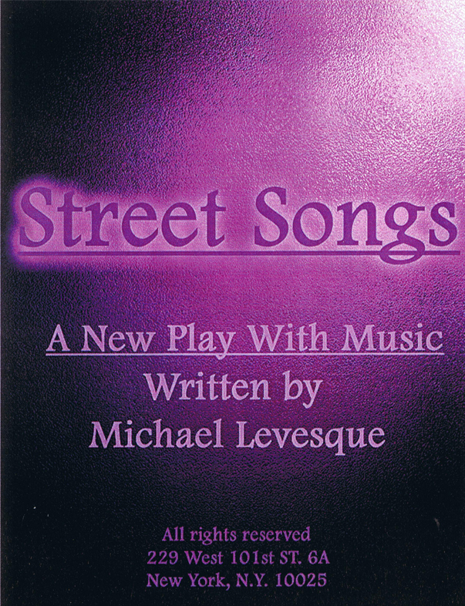
Synopsis:
This piece is still in progress. Six actors play street performers and tell the stories through song and words about how these particular people have ended up n the street and how we’re all too busy to stop listen to their song. Everybody has a song.
Cast List
RHONDA: A child
SALLY: A Mother

PHILLIP: A Soldier.

KENNETH: A Father.
JORDON: A Poet.
NATASHA: Prophet.
All Rights Reserved

Sample Script
ACT ONE
(The house lights go black. A street light come up. You see one of the street Musicians playing a song. The actors all enter. They are all dressed in a basic black outfits. Another street lamp comes up and reveals the first actor.)
SALLY
Song: a brief musical composition for singing, a lyric poem or ballad.
PHILLIP
(Another light comes up) Composition: The arrangement of parts composed, process or technique in structuring music or art.

JORDON
Poem: A verbal composition having the suggestive power to engage the feelings and imagination,
KENNETH
Typically through the highly structured patterning and movements of sound, rhythm, and meanings characteristic of verse.
NATASHA
(another light) Lyric: The words of a song. Of or relating to poetry that is a direct, often song like expression of the poets thoughts and feelings.
RHONDA
Feelings:(pause) Sensibilities. Opinions. Sympathy. Easily moved emotionally.
SALLY
Street: A public way or thoroughfare, as in a city or town,

PHILLIP
Street person: The people living along such a roadway.
JORDAN
Aimless, homeless, Pauper, beggar, indigent, Bankrupt, dependant, Destitute,
KENNETH
have not, debtor, Mendicant, insolvent, panhandler, Supplicant, suppliant, sponge, moocher,
NATASHA
almsman, cadger, leech, parasite, Transient, tramp, hobo, vagabond, vagrant, derelict,
RHONDA
drunk, Good-for-nothing, wino, loafer, ne’er-do-well, rouge, wanderer, idler, drifter, sluggard,
SALLY
slouch, lounger,

PHILLIP
lazybones, malingerer,

JORDON
wastrel,
KENNETH
shirker,

NATASHA
laggard,

RHONDA
sluggard,
ALL (Together)
drone, prolifagate, degenerate, dissolute BUM!!!

SALLY/ PHILLIP
Street!
ALL
Songs!

JORDON/KENNETH
Street!

ALL
Songs!
NATASHA/RHONDA
Street!
ALL
Songs! STREET SONGS!

SALLY
So you live in a city....
PHILLIP
San Francisco.

JORDON
Chicago.

KENNETH
Boston.

NATASHA
Cleveland.
RHONDA
Dallas.

ALL
Dallas?

RHONDA
And Houston.

PHILLIP
Any city in this great country of ours.
JORDON
You’ve all seen them.
KENNETH
Tall. Short.
NATASHA
Black. White.

RHONDA
Gay. Straight.
JORDON
Fat and thin.
SALLY
All homeless.

KENNETH
All hungry.
ALL
All human.
KENNETH
So you ask yourselves....Who are they?
SALLY
Sally.
PHILLIP
Phillip.
JORDON
Jordon.
RHONDA
Rhonda.
NATAHSA
Natasha
KENNETH
Kenneth.
ALL
People.

NATAHSA
And what are they?
RHONDA
Children.
SALLY
Mothers.

PHILLIP
Soldiers.

KENNETH
Fathers.
JORDON
Poets.
NATASHA
Prophets.
ALL
Just people.
RHONDA
What do they want? (pause) I said what do they want?(the drums stop) I said WHAT DO THEY WANT?? Hello!! Anybody???
SALLY
I don’t know that’s a good question...Money?
JORDON
Sure.....but is that what they really want?
RHONDA
What do you mean? Of course they need money. That’s why most of them say spare change...Got a quarter?
PHILLIP
No...he means like they want to be loved more or something like that, right?

NATASHA
Well don’t we all want that? No, I think what he means is...
PHILLIP
Come on...A lot of these guys, and girls are very fit...They could find jobs...They probably make more money then I do in a day...

KENNETH
Compassion.

NATASHA
Excuse me you just interrupted me.
PHILLIP
No, he interrupted me.
NATASHA
I was talking to you!
KENNETH
Compassion is what they need.

NATASHA
Again, don’t we all want that?

SALLY
A home...the American dream they want a home....

RHONDA
A home? Don’t you think that food would be a little more important then a home? Not to mention practical.
SALLY
Well then you tell me.
PHILLIP
I think that....(they all start ad libbing about what they think it is street people need)

JORDON
Hey!! HEY!!! What makes us think we could possibly know what they want...or need?

NATASHA
You’re right... Or why any of them are even there in the first place.

RHONDA
I know one street woman in my neighborhood...

KENNETH
You do?
RHONDA
Yeah....
KENNETH
And why is she there?
RHONDA
I don’t know.
KENNETH
You never asked?
RHONDA
No I thought it would be rude...

NATAHSA
You don’t think it’s rude to ask me what I do.
PHILLIP
We all know what you do...You’re an actress... we work with you.

NATASHA
That’s not the point.

SALLY
Well how many street people do you know?

KENNETH
That’s not the point.
SALLY
What’s your point then?
RHONDA
Yeah what’s your point... (they all start ad libbing)

JORDON
Hey! HEY!!! The point is we don’t know who they are or anything about them. We live here in New York City with over (number) homeless people and most of us know nothing about them.

NATASHA
You’re right we walk right by them....most of the time.
KENNETH
And when we do stop. We give them what we think they need....
RHONDA
Which may have nothing to do with...
PHILLIP
What they really need.

JORDON
Or, what if they don’t need anything at all? What if they just have a song to sing. Everyone has a song to sing and there are over(number again)Street songs in this city. We put on Music everyday and sit and listen to the music and the lyrics....

SALLY
I love some of those guys in the subway. You know the singers and musicians...
KENNETH
Or some of the people right on the streets.
RHONDA
Some of them are so great....
NATASHA
I think what Jordon is also saying is what about their lyrics? A song isn’t complete without the lyrics....The story the song tells.
JORDON
Exactly....and every song is as different as every street.
KENNETH
Now we’re back on track....Street songs....(the drums start up again) Thank you.
We walk by so fast that all we ever hear is.

