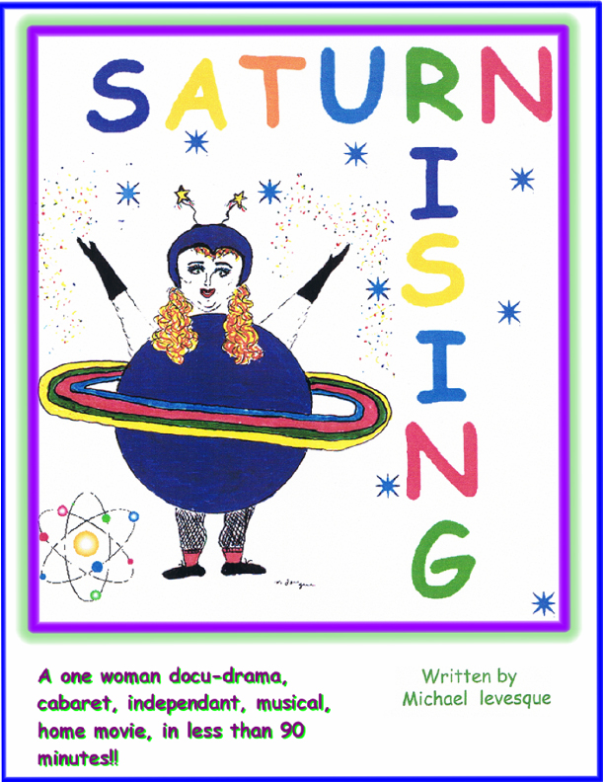
All Rights Reserved

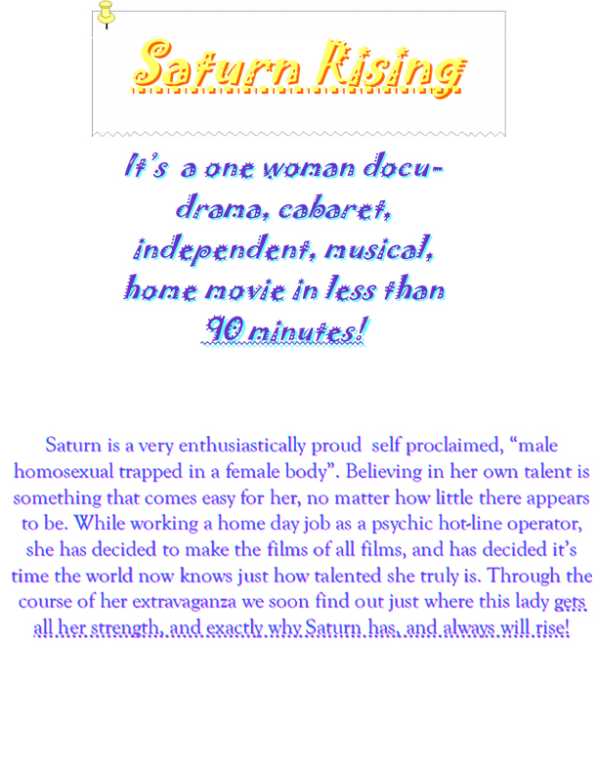
This piece is not complete yet but here is a brief sample
ACT ONE

(She is a zoftig woman in her late thirties to mid forties. The set is a work area in her home a chair and a desk a phone. She should have a camera set up a costume rack with props etc. as the show opens she is sitting at her desk with the phone her tarot cards etc.. The phone rings)

SATURN
(Answering) Saturn rising! This is Saturn. Yes, that’s correct. I put the chic in Psychic. That’s right baby…Wait, wait, wait...WAIT! Just hold on their tiger, Visa, Master card, Amex or Discovery?...Hmm…hmm…Oh platinum...good for you...hmm..hmm...Credit card number…hm...hmm…Date of Expiration hm...hm....All right. This is Saturn, the Queen of the unseen. What can I do you for? I have tarot, horoscope, runes, or just a plain old fashioned run of the mill clairvoyant reading. What will it be today Sir? Pardon? Oh no, no, no, no, no! There are 900 numbers for that! Excuse me sir…I think I’m going to hang up now. I don’t care about that! OH sir...,I don’t want to hear about your oversized foreskin! Hey!! HEY! STOP IT!! What part of this conversation don’t you understand you demented fuck? I’m going to call and report you. This is not that kind of a number. OH...OH...you’re disgusting! Your mother must be one sorry bitch to have ever let a filthy pig, little shit like you, plop into this world. Too bad her flush reflex wasn’t faster. No! NO!! Fuck you! FUCK YOU!! Yeah??? Well, why don’t you get down on your knees and kiss my fat cellulite ass hole pucker, you mother fucker? Yeah? Yeah, you think so huh? You couldn’t even if you tried you dickless shit head. Dickless shit head. DICKLESS SlIT BIEAD!!!(Pause)
Yeah, yeah, yeah, whatever…Whatever....Hey, it’s your dollar. What ever floats your boat baby. No…No! I know your voice. I did...I do every time. No, you didn’t sound like you were Brazilian, Mr. Rosenbaum....I’m sorry. Hey, maybe one of these times you will really want a reading Yeah, we can look at why you get so much enjoyment out of this kind of perverse degradation....hello? Mr. Rosenbaum?? HELLO?? What a creep! As long as he came, that’s all he cared about. (She pulls the phone jack out of the wall, goes to her costume rack and puts on her first costume the Saturn costume, walks over to the camera and puts it on, then presses her tape recorder and performs her first number. Saturn Rising.)

SONG SATURN RISING
(Panting) Thank you. Thank you very much. In case you’re wondering, this is my...NO! NO!! Wait...WAIT!! Let me start again...Oh shit I should start all over. No, no, no, no, no, no, no, no, no.
I’m just going to let the camera’s keep rolling no matter what. That’s what this is all about. Right? Right. I’m talking to myself right now in case you didn’t notice. Don’t worry that’s very common among us over talented creative types. That was just a little detour as well, which is also common among us geniuses, and I am a genius. Let’s just get that out of the way now. That way if my talent or my geniusness intimidates you, or overwhelms you, or nauseates you, you can leave now. Oh and lets not forget you must be at least this high (holds up hand) to go on this ride.
Where was I? Oh God I’m off to such a great start. You’re really getting to see brilliance in operation. Sometimes it’s not easy you know. Sometimes I feel like I have so much talent mixed with so much genius topped with so much brilliance that I think I’m just going to explode. Then I realize I just need to fart. That’s all. Did I forget to mention toilet humor in the mix there?

Oh GOD I excite myself!! In the past five minutes I have been insightful, witty, humorous and awesome. Awesome in reference to my outstanding opening number. Not to mention my way to subliminally help the worst specious to ever inhabit this glorious paradise we call earth, critics. This is my way to help you discover the adjectives you have never fully been able to find to describe my brilliance.
Now where was I? Oh...oh yes. (ala Shakespeare) To start over or not to start over that was the question... See I also dabble in the classics. (deep breath) OUT OUT DAMN SPOT! She was obviously wearing white pants at the wrong time of the month. You see now, I couldn’t start over. You’ve seen too much already. I’m on a roll. This is good stuff…doo da, doo da... Besides that’s what this is all about isn’t it?? Keep it (sing this) rolling, rolling, rolling with the movie, rolling with the movie....Our little ambitious blonde did it in truth or dare. Those horsy homely drags vogued it in the burning city of Paris, and somewhere in that heart of darkness Mrs. F. F. Coppola achieved the same thing in apocalyptic proportions. History is on my side. (she adjusts herself) So are my tits, this damn push up bra… Excuse me.
Where was I? Oh yeah...NO! I WILL NOT, I CANNOT START OVER!!! So fuck you! This is me, all of me. There, that’s it. What you see is what you get, or verse visa, what you get is what you see. Think about it. Huh? Deep isn’t it? You thought I was just all talent and no substance didn’t you? WRONG!! Baby this river is deep, my ocean is wide, but it’s too early to get that deep yet. We’ll start shallow and breast stroke our way down to the deep end. Nice and gentle. Then when you’re least expecting it I’ll throw you off that mother fucking high dive right into that deep end. Ooooh baby it sounds like a hot time in the old girl tonight. Doesn’t it? Stop this! I’m exciting myself! Oh boy it’s hot in here. Secret.... I’m not wearing panties. If you’re nice I might even show you some of my basic instincts. You think Sharon has something I don’t? Oh you are so wrong baby....you haven’t seen anything yet....oh God I have to stop this...the last thing I need is a big old wet spot on this outfit, or to be sticking to the stool every time I get up. There’s nothing worse than that suction, snapping sound as you release the stool as you’re about to embark on your next musical journey. It isn’t pretty. Actually there is one thing worse. Sticky stool, there I said it. This show isn’t for the weak at stomach. God I sound like that geek, creep, Rosenbaum. Oh you don’t even know who that is, do you. Trust me you don’t need too. But Hey Fuck It! That’s me, all of me. The Profound and the profane.
Seriously now, I’m Saturn. Actually Saturn’s just my handle for my job job. Yes, I know it’s hard to believe I still have a job job. I know you’re all probably sitting there right now saying “wow, can you believe that she was an unknown till she did this project.” Just till this is released in all the major movie houses and I’m discovered across America, when that happens, then I’ll quit my day job. I work as an operator for a Psychic hot line. I put the chic in psychic. That’s what I tell all my customers.
So where was I? Saturn! Yes, Saturn is not my real name. My real name is Bette, named after the one and only Mrs. Skeffington, Bette Davis. My mothers favorite movie was now Voyager ....oh god I guess... that would make me... her Charlotte. Oh god! I never really thought of that before. Oh god, I’m Charlotte??? Do you think that’s what this all means? Before or after the voyage? Oh the mystery of it all. You know what? I don’t really care why that woman did anything. That’s probably the most honest thing I’ve said in this piece so far, except for the part about all my talent mixed in with all my genius and brilliance, ladaldalada.
SO!! (clears throat) Welcome to my one women, musical, psychic, docu drama, independent, home movie, cabaret! TA DA!!! Thank you very much....You’re all too kind. Well, almost too kind. That basically means I could be eligible at some point in time to win an Obie, Drama desk, Tony, Play or Musical, Oscar, Grammy, Emmy, Bistro, MAC, or at the very least my own booth at the whole life expo. Move over Rita Moreno. You know what they say, it’s not about winning it’s how you play the game. FUCK THAT SHIT!!! It’s all about winning baby. You know some big old loser thought that god damn thing up. It’s all about winning. Getting that brass ring, crossing that finish line, giving that acceptance speech, making that yellow light, getting that last seat on the subway, cumming first! Right? WRONG!!!
Whew....took you on a little journey there didn’t I? Through you off just a little bit, didn’t I? Come on be honest. You were all sitting there eating your junk food, your fiddle faddle, little reccees pieces, kit kat, butter finger, B&J”s chunky monkey, beef jerky, sausalito, mint milano, fat free intimans, barbecued baked lays, thinking this is one obsessed, sick bitch weren’t you? Well, that’s just part of my brilliance. I bet you thought that last part was rehearsed. WRONG! That’s just my weekly shopping list, so I have it memorized. Keep up with me kids we’re going for it, all right?? Good! NO! I used to think that way but not anymore. I believe... No! I just can’t keep out of the deep end, can I? That’s what my cx husband use to say if you get my drift-a-roo. Ow that hurts! You know if just once I could meet a man who believed the same way I did...heaven. Yeah well …we’ll get to that one later….the male species that is.
Speaking of which...A transition …I am a male homosexual trapped in a female body. I know this. It took me years to figure this out and I’m a lot happier now that I know it. What does that mean? Hmm....How can I sum this up? Basically it means, I’m creative, tasteful, sensitive, I love sex, decorating, Ginger, Judy, Cat woman, Joan, Bette, Barbra and dick! And I don’t mean Nixon. The only difference is I have real tits and I’m hung like a doughnut. Some would and do call me a glorified fag hag. Obviously they’re not conasoirs when it comes to the fine details of human sexuality. Trust me, I am. I am a self proclaimed expert with years of experience. I have spent years on research and experiments. I’ve even gone a few digs in my time, if you get my drift-a roo.
Enough of this, and on with the show. Oh...this is the show. The show that’s right. The reason I’m doing this show is for years....years’ people have been telling me Saturn, you’re very talented, and I would say, I know. That’s basically it, that’s the reason why. The thing is they say I’m talented but the truth is they just don’t get it. They don’t get me. I reiterate, they just don’t get it. Who’s they, you ask yourself? THEY! You know, the same they that says everything on this planet when you really can’t remember who said it in the first place. You know...they said it. THEY! Though in this case, I do remember who they are. They are the entertainment establishment. I overwhelm them. I see it physically. I am too much for them. I intimidate them. I truly believe that I am the proof that there is such a thing as too much of a good thing. This is it, here I am.
I mean I do it all, and this one woman, musical, psychic, docu drama, independent, home movie, cabaret, will prove it. Not that I’m out to prove anything. I’m not…I swear I’m not That’s ridiculous! Don’t think that for a second...I mean...how fucking insane is that? When you know you got it, you know. You don’t even have to prove it or defend it or anything. You just know all right? So at the end of this one women, musical, psychic, docu drama, independent, home movie cabaret, when there’s a phone number so you can all call and order your own copy, which I’m convinced you all will, of this break through work of art, don’t be calling just to challenge me on this. Alright? This is my home number I don’t need you bugging me all day long because it pushes all your buttons. Are we straight about this? Great!
Let me set the record straight once and only once, I know I have talent. I can’t explain it. It’s unquestionable. It’s like knowing you hair...or not...sorry. Or like you know you have eyes or a body, you know? You just know! Alright? Good!
God I just hate that people can’t accept it when people are confident of who and what they are. I mean that’s what really gets me. It goes back to what I said earlier, you see what you get. You know? Of course you don’t that’s one of the reasons you’re so drawn to this art, to understand what that means. I’ll explain it later when were wading in that deep end.

