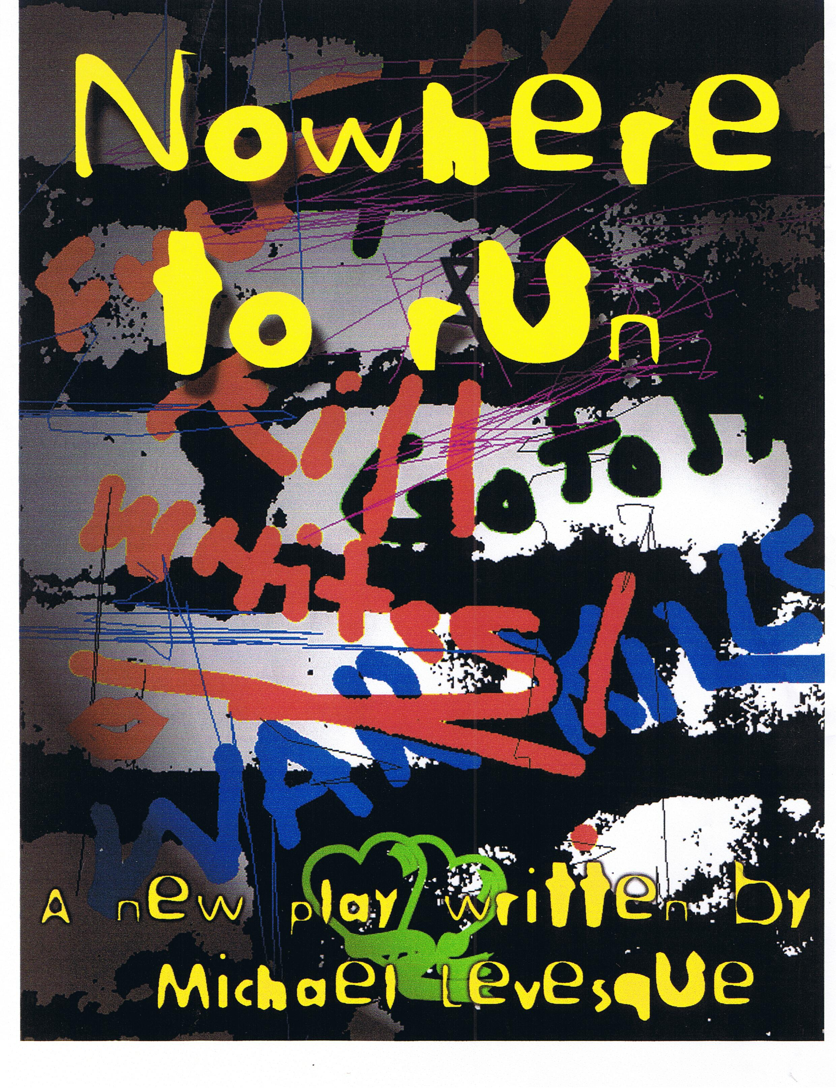
CAST LIST
MAJESTIC: The leader of the gang. Black. Tough.
PEACHES: More feminine than some of the others. Been known to sleep with Coffee. Black

COFFEE: Gay; Real tough. One of the hardest of gang members. Black
ROSIE: One of the smartest of the gang members. Black
ASHES: Fast, and clever. One of the spies for the gang, loves to fight. Black.
JUNKIE: The junkie of the gang, strung out most of time. Black.
CHEESE: One of the youngest of the gang members. She is Peaches cousin.

Synopsis
Detroit Michigan, 1971. Poor, black and female is the plight of these female gang members. The time is coming out of the 60’s and entering into the 70’s, a time when one of the only ways for women under these conditions to get out was to form a singing group, or so they thought. These girls are tough and hard. Most research on woman gangs of that time was non existent because women were not even in the employment force to be able to research this. What research there is, moves beyond the thought of the time, which was the only purpose women gangs served was sex for the men gangs. Not true. These girls were just as tough in some cases even tougher. This is one such story, written using a modern day rap dictionary to bring a more contemporized feeling to the piece. The story follows a typical day in the life of a gang member, fighting, stealing, drugs, sex and the possibility of being killed at any moment, just another day at work. Some wanting in the gang, some wanting out, all realizing, there’s Nowhere to Run.
ACT ONE
(The stage is black. Curtain drawn. The time is fall 1971. Detroit Michigan. The first light comes up on Majestic)

MAJESTIC
Detroit, Michigan. (blackout. Special up on Peaches)
PEACHES
1971(blackout. Special up on Coffee)
COFFEE
East side.(blackout special up on Rosie)
ROSIE
Three things we all had in common.(blackout.)
PEACHES
(special on Peaches) Poor. (Spot on the back of a Vandella(Junkie). Then blackout on Peaches.)
COFFEE
(special on Coffee) Black.(Spot on the back of second Vandella(Cheese). Blackout on Coffee)
ALL(MAJESTIC/COFFEE/ROSIE/PEACES)
(specials up) and female...(spot up on Martha(Ashes)(of the Vandellas) Black except on Martha and the Vandella’s. You hear the music to “Dancing in the Street” start as the three girls turn to sing the song(lip synch) immediate blackout. After the first few lines of the song the curtain opens revealing the set. The set should represent an abstract version of poor inner city life with different levels and playing areas. Maybe a scaffold, lots of graffiti, also posters etc..representing the time. During the song “Dancing in the Street” there should be small vignettes using the women representing the crimes they commit. I.E. someone running out of a store ripping off liquor. A confrontation between a couple of the girls. Stealing a purse... Ending with all the girls starting to gather in an area of the set that should represent a run down vacant flat they have taken over. There should be a couch a table and some chairs, a TV etc. They are getting ready for their meeting. Majestic, Coffee, Peaches, and Rosie are now settled down in the flat. The last thing you should see is Ashes run across the stage as the song “Dancing in the Streets” has ended. She has just ripped off a stereo turn table. Majestic and Coffee are sitting at the table rolling a joint and drinking. Peaches is curled up on the couch watching TV(Gilligans Island). Rosie is pacing.
COFFEE
Why you watching that stale ass shit girl?
PEACHES
Leave me alone, I like this stale ass shit alright?
COFFEE
But you know how the mother fucker ends.
PEACHES
I don’t care that they’re fucking re-runs, now shut up...
COFFEE
You dummin ass nigga, I’m not talking about re-runs...I’m talking ‘bout how those poor ass caveman crackers are never getting off that mother fucking island. Face it girl, they be stuck for life.
ROSIE
Yeah, and where are all the black folks on that damn island huh? Where are they?
MAJESTIC
Black folks just too fucking poor to be on that stinky ass boat...( they all laugh)
ROSIE
So...Where is everyone, huh?

PEACHES
(laughs)Sister, slow your roll, cause you be talking some real bunk. Everyone?? Shit!
ROSIE
You mean more sisters dropped out? What was the shit this time huh? Black Panthers, All African Peoples Union, Nation of fucking Islam, or the ever popular NAACP? Shit! I’m telling you things are changing Majestic...We should wise up...
COFFEE
Shut the fuck up Rosie you're twisted!
ROSIE
I haven’t drank a God damn thing! Or...or maybe it’s this women’s lib crap..huh? I’m telling you things are changing..You nuckers are just gonna play the deaf ear bullshit...Act all stupid and dumb...try to keep it all down low right? Maybe y’all need to stop playing the fools and asks yourselves if that’s why we keep losing homegirls by the dozens..huh? ‘Cause they ain’t all in the boneyard I can tell you that! Dig?

COFFEE
Shit....it’s not about the numbers rambling Rosie...It’s the about the heart of the homies you got. Right? The skill...right? We’ll just let all those ugly ass housenigger’s fucking leave...as long as we got the players right? The ones who are true to the game...Right?
PEACHES
Right.
ROSIE
Players? True to the game??

COFFEE
That’s what I said...Are you with me R?
ROSIE
Oh..I’m with you...I’m a player....but where the fuck are the rest of them? Huh? Or are there even any more coming huh? Shit!
MAJESTIC
They’ll be here.(taking a swig and passing the bottle)Crack a brew Rosie....
COFFEE
Yeah calm down and chill out Rosie bud, you be tripping. You be losing all your fucking petal's girl...
ROSIE
I’m not tripping.
COFFEE
Well then I sure as fuck would hate to come face to face with tripping....Cause you are most definitely bugging me out....Shit girl have some juice and marinate...Or better yet....(pass's joint) Here, have some Bo...It’s colum...Go ahead..it’ll calm you down.
PEACHES
She’s getting too good for our shit now...Don’t you know?

COFFEE
To good for Colombian? What the fuck....
ROSIE
Hey! Why you gotta be talking smack Peaches? Huh? Here...(she grabs the Joint)
COFFEE
Yeah...Peaches...Everything is everything ‘right Rosie? Our Rosie girl is most definitely a player ‘right?? Right??
ROSIE
Right(she takes a huge hit)

COFFEE
Look at that fool, she be having them vacuum lungs....(Rosie exhales)

ROSIE
Whoa...this shit is chronic....

PEACHES
Chronic like your skanky bowels...(they all react)

ROSIE
Peaches why you talking bout my shit?
COFFEE
Yeah girl you be illin...
PEACHES
I’m just making sure everything is everything with you Rosie girl. Dig?
ROSIE
Yeah I dig....
COFFEE
(Going to Peaches) See my little boo Peaches..everything is everything(goes to kiss her)
PEACHES
Hey! Knock it off right?...cut the shit....(she pushes her away)
COFFEE
Hey!(she pushes Peaches back)Maybe if I beat on your shit real hard, fuck you up real good, you’ll like me again ‘right?
PEACHES
Fuck you! You are one ill mother fucker!

COFFEE
Who the fuck you calling ill, you little psycho shit, ill headed, mother fucking mental, bizzo?(ad lib yelling at each other)
MAJESTIC
Hey! HEY!!!(they stop)You two start bumping titties and I may have to pop cap in your sorry black ass just to shut you mother fuckers up!

COFFEE
(Backs away. To Peaches) Fucking, ruthless bitch tease....You’re brick man...brick.
PEACHES
Bitch tease?!? Hey Majestic, check this out!

MAJESTIC
Hey I don’t want to be in the middle.....
PEACHES
No, check this out. You with me? I told this sorry ass bitch, we were done. Right? So I thought everything is everything, right? No! She hasn’t let me rest....Not a mother fucking minute...Man, she be gamin’ on me, grabbing me, poking me, trying to get me to go that way again.. Not that that way is bad man it’s not... But just not for me, right now ‘right? And then when I tell her no man, she’d be talking smack, all crazy and shit. Skitzing, you know? You can be one scary mother fucking bitch, you know? (Coffee smiles)Smoking to much of that bo...That’s the problem...That colum will make you crazy.....Here let me have it Rosie..You’ve been hogging that shit for the past ten minutes....

COFFEE
You finished?
ROSIE
Come on you guys...
PEACHES
Yeah I’m finished....
MAJESTIC
You’re both really starting to ....

COFFEE
‘Right, check this out...When was the last time we met?...Formally...
MAJESTIC
Shit, I don’t...

ROSIE
About two weeks ago...

COFFEE
‘right? Right. So about two weeks ago...You know we’re leaving the mother fucking meeting...and little Peaches says to me...Where’s your kid tonight? I say’s at my Granny’s why? Right? She says “cause I could sure use some sugar tonight”...Right? The little bitch tease wants to give me some little sweet mother fucking coochie ho cake, right?
PEACHES
Liar! This is bunk! You be talking shit!
COFFEE
Oh!!! Who be talking shit, you little lying ho?
MAJESTIC
Hey! No one here is a ho!
COFFEE
Shit Majestic, she’d be telling another mother fucking lie and she knows it! She ain’t right! That mother fucking Peach is rotten!

MAJESTIC
Hey no sister on sister here Coffee...
COFFEE
Hey I here you Jestic...I swear this ain’t no Sister on sister...But she gave you her side now I give you mine...See girl they are two of us here...One...two...You heard one sick mother fucking side...Now you hearing the real deal....That’s why that bitch keep barking and being all disrespectful....interrupting and lying!

PEACHES
I’m not lying!
COFFEE
MOTHER FUCKER! Now you know me M, I may be a nucker, I may be one ugly, tough, hard ass bitch, but I do not mother fucking lie! Right?
MAJESTIC
Right! Peaches?!! Show and prove girl.
PEACHES
(pause) Right...maybe I did fucking say that...right? I don’t ‘member...

COFFEE
Right.
PEACHES
Too much bo, I’m telling you...it’s fucking with my mind.
ROSIE
Then stop smoking it, here...(goes to take it)
PEACHES
I ain’t done yet..back off, will ya? You’re not my mother fucking mother...
ROSIE
No you’re as sure as shit about that shit, I’m not. 'cause if I was your ugly bitch fat ass mother, come ‘bout right now, I’d best be pounding on that mother fucking head, getting ready to push a skull right through that mother fucking window, then grabbing that big, fat ass, base ball bat....
PEACHES
Alright!! That’s what I said, you’re not my mother fucking mother, right?
ROSIE
Right.

COFFEE
When you bitches are through I’d like to finish my mother fucking story, right?
MAJESTIC
Go ahead.
COFFEE
Crack me a brew.. So I was saying, the Peach said she be needing some sweet ass sugar, right? So check this shit out...So I be thinking, this is cool right? I mean.. I’m getting all hot and wet and juicy, ‘right? I mean my drawers are drooling and my loins are burning...My god damn nappy dugout is sweatin sweet beads of Jesus!
ROSIE
Alright we got your shit...Girl, why you be talking that shit, huh? You try to get me illin?
COFFEE
Well come on, we all know there ain’t nothing sweeter than the meat closes to the pit of the peach Right?(Majestic laughs)

PEACHES
Fuck Coffee! See this is why...I don’t need my family...Like..like... everyone knowing my all my shit...'right? You think I’m like a trophy or something for you...Or...

COFFEE
(yells violently) THAT IS NOT FUCKING WHY AND YOU KNOW IT!(she punches the wall)

MAJESTIC
Coffee!! Chill out girl....Just chill out alright?

ROSIE
Shit!
PEACHES
She’s bugging Jestic....She’s getting as fucking crazy as Junkie...
ROSIE
Peaches, girl you are looking to get your sorry ass skinned if you don’t watch your shit and shut your dirty ass hole!
COFFEE
ause)That is not fucking why, and you know it...In fact, you always liked the way I ate my peaches...or so you said...Or were you lying then too?

MAJESTIC
Peaches?? You best not be lying to your sisters in the hood you hear? We don’t mess with each other here, ‘specially when it comes to matters of the heart, alright? Huh? “cause if that shit she be saying is true, that is cold girl. She be right, you are brick...(pause. Peaches just stares) Shit girl, you just played yourself, you know?

PEACHES
Alright! So maybe I did like it...I mean why not huean why not huh? The bitch looks just like a nuttin’ cock diesel punk ass man, why wouldn’t she eat

ike one too
COFFEE(pause. then Coffee breaks out in laughter) Now we all that be another mother fucking lie, ‘cause how many brothers you been with that ever even gets near that sweet, juicy peach ‘right?(they all laugh) Pass me the weed.
ROSIE
Ain’t that the fucking truth. You got that right sister...
COFFEE
Right? So check this out...We book from the meeting. we get maybe five minutes out the mother fucking door and that mother fucker punk ass Fang blind sides her, and starts beating in her man....
MAJESTIC
Is that true?
COFFEE
You damn right it’s true. I ain’t be talking no shit here.
MAJESTIC
Peaches?
PEACHES
Everything is everything
COFFEE
No, everything is not everything! So this mother fucking is beating shit on her, Jumping all over her sorry ass. Strong arming her like there be no tomorrow...At first I reach for my hardware and ‘member I be leaving my double deuce here...so I start to jump in, because I know I can do some serious shit to this mother fucking hook with or without hardware...I could serve him real good right? And this crazy bitch yells “don’t! Stop! Leave him be....”
MAJESTIC
What?
COFFEE
‘right.
ROSIE
(pause)So...what happened
COFFEE
So there we are....I’m standing there be giving this rat ass, wacked job, hard looks, you know.... scoping his shit out, hawking him up and down and inside and out...I mean, I be seeing red, you dig... I be all ready to get wet and get a mother fucking body with my bare hands....This cat’s just blown off on her...Right? Fucked her up real good.. Her lips bleeding, cut her eye, and home boys standing there holding a handful of Peaches fuzz in his scrawny ass, shit hole, fist...
ROSIE
(Pause) Yeah...and....
COFFEE
(pause. Peaches looks at Coffee there’s a moment)...and ...nothing....(looks at others)Nothing...
ROSIE
Nothing my ass....What the fuck happened? Come on, back your shit up girl!
COFFEE
Ask her... “Sweet” boo Peaches...
MAJESTIC
Peaches? Peaches!
PEACHES
What?
ROSIE
What happened?
PEACHES
Like she said....nothing....
COFFEE
(pause) Nothing but the stupid ho walking away with that punk ass fang...and now they’re hanging together...Knocking boots and every thing, right?
PEACHES
(to Majestic) Hey, I thought you said there be no ho’s here
.
ROSIE
Oh fuck Peaches....
PEACHES
(to Rosie)Just because you don’t have an old man!
ROSIE
I don’t want an old man like that girl....Jesus, wake up!
PEACHES
I am awake...Pass the shit will ya?(they pass her the bottle)
ROSIE
Why you always letting people be beating on you girl? Your mother, father, brother, uncle,
dog, cat,....
PEACHES
(yells) HEY! NO! No, no, no!!! Don’t you be talking shit to me Rosie! That’s why I run away, alright? That’s why I grabbed my two kids and got my mother fucking sorry ass out of there! So you don’t you be talking no shit to me alright?
ROSIE
Well then run away again...from this...He’s no good girl....You know it...
PEACHES
(pause) No....
MAJESTIC
Damn it girl! What’s you doing huh? You trying to make us look like sorry weak ass cute girls or something? You trying to make us look like fools? Girl, we are trying to be independent here you know? We are trying to be separate from the brothers, right? That’s why we changed our names from Vice Queens to our own name..
COFFEE
The Black Bangers...
MAJESTIC
That’s right....We no longer be indebted to the brothers, dig? Wther fucking punk ass cats nuttin...We don’t have to be there hoodrats any more...alright? No more holding the brother's hardware when they be going to war, our holding there Jammies when they feel like they want to be boning our mother fucking Jennies, you hear? We gone and proved ourselves alright? Everything is everything with our Brothers....Shit, we’re so bad, we even got the God damn brothers blessing....Do ya know what I be saying girl?

PEACHES
Well the fuck was I supposed to do huh?
COFFEE
You could have said no, fuck off, I’m taken....Or you could have just kicked Fang boy in the bozack and bounced.
PEACHES
Know one has ever cared that much for me alright?
ROSIE
That’s not caring Peaches.

PEACHES
The old man’s gotta rep for making good with his homegirls ‘right? He’s gonna take care of me. Maybe even be giving me $10.00 or $20.00 a week...
ROSIE
Right....

COFFEE
Shit! You be slipping Peaches... ‘Cause now you be nothing more than a sellout sack chaser...And your sweet Pussy cat will be burning butt good, ‘cause he ain’t nothing but a no good, lacking, crazy coochie chaser, who be sticking that jammy everywhere he can....You know what I’m saying? You best watch yourself...mark my words...Any day now you be getting the burn.
PEACHES
I already have...

COFFEE
Mother fucker!!
MAJESTIC
Alright, alright chill! Both of you just marinate alright? I don’triant to be hearing no more of your shit! From now on this here is your own private business, you hear? I want you two cats to get down with each other and slap some skin...(they do) That’s my sisters...Now, you best be listening to me Peaches, you hear? It’s your life alright?...But you be our sister, not some brothers ho, dig? Don’t ever forget that....(they hug)
PEACHES
Now you be talking shit, alright?...I could never forget that...I love you girls...(to Coffee) Even you, you crazy bitch...I’m ‘bout it right? Everything is everything....really...You’re my family ...he’s just an old head homeboy who’s trying to make good on his bitch...that’ all...right?
COFFEE
I could have made good on you too....
PEACHES
I know.....
COFFEE
(pause)You could have at least let me put that mother fucker in his righteous place, alright...(she sits down to roll another joint)

MAJESTIC
It’s a good you didn’t...Even though we’re separate now, we still gotta share the turf...you know... They’ve been real good about backing our asses up....(Ashes enters carrying a stereo) Hey, hey...Ashes!
ASHES
Hey...sorry I’m late....
COFFEE
Way to go booster girl...coming through on the en-ter-tain-a-ment center...Now that’s what I call a good home girl...looking after her sista’s like that....Give me some skin bitch..(they do)

ROSIE
What the hell have you got there?
ASHES
What happened to you? Get tired of looking at your ugly ass afro head face in the mirror and cut your own balls outa your skull? It’s a turn table to hook up to the rest of the system....

ROSIE
I didn’t know the old one was missing.....
PEACHES
Yeah...Junkie took the old one and sold the mother fucker for some H....
MAJESTIC
Hey we don’t know that!

COFFEE
Yeah Peaches, back your shit up! 'right?
MAJESTIC
Yeah you best begin to show and prove girl.
PEACHES
Shit! Show and prove, show and prove....We all be knowing it, we’re just acting like dumb mother fuckers, pretending there could be some other wacked out story ....Alright...Shit! Check this out, you with me? The bitch stole three pairs of my hot ass jeans to sell to get all crazy and shit... Y’all know that! When J’s not crazy on H, she be all dusted on that other shit! Dig?
MAJESTIC
Alright, that’s cool, you showed and proved. You’re ‘bout it right? We all ‘member what P‘mches is saying is right, right?
ROSIE
Right...And we did her a second chance too, but then she is our sister, right? A sista is a sista..... We just can’t hang her out, ‘specially when so many other cats are getting out....Maybe she’s clean now.
COFFEE
‘right? Yeah...maybe....
PEACHES
‘Right...Ya’ll is dummin! Come on, if that bitch’s clean then my old man is sober and stopped beating down on my ugly fat assed Mama..’ight?
ROSIE
Maybe some booster from around the way be busting in and ripping off the old one....
PEACHES
Who the fuck is gonna fuck with us ‘right? We are it! We are ballin!! We are the Black Bangers! The toughest sisters D town has ever seen...They all know they be fucking with us and we be beating them down and tearing them up....We are bad...Face it, it was the Junkie thief again...
ROSIE
Hey, we don’t that for sure.
MAJESTIC
She’s right we know ‘bout the jeans but...

ROSIE
But what?? Like I said ‘fore ya’ll is dummin...

MAJESTIC
Just back your shit up Peaches....That’s all I ask.
PEACHES
I don’t have to...Ashes?
ASHES
What?

PEACHES
Go ahead...(they all stare at Ashes)
ASHES
Go ahead and what...why ya’ll be turning your mother fucking ugly faces my way huh? (no one answers) Shit! Why you be talking shit again Peaches? Huh? Always trying to get down on the other sisters, right?
PEACHES
Wrong...I ain’t taking shit and you know it..tell em what you told me or I will tell em myself...You better set this shit right and deal with it. 'right? I’m ‘bout it, right? Everything is everything Ashes, you know that.
MAJESTIC
Ashes? Show and prove...
ASHES
Alright....She’s right...It was Jackie....
PEACHES
Junkie!
COFFEE
Mother fucker!
ASHES
She booked with it and tried to sell it to some cheap ho over on the west side so she could buy some shit....

ROSIE
Jesus!
COFFEE
She’s fucking crazy, that bitch is...
MAJESTIC
Back your shit up!

