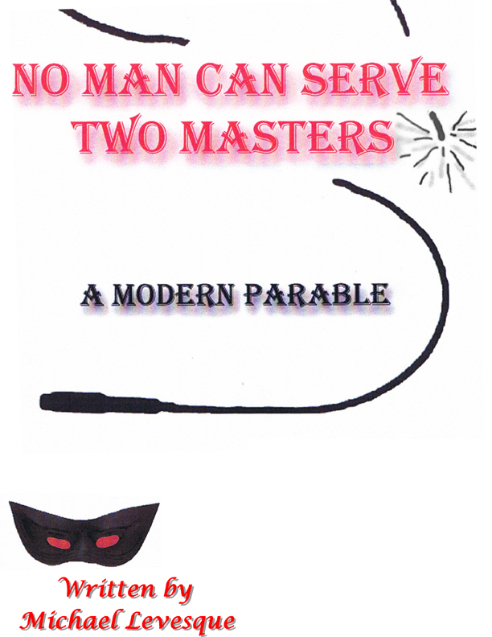
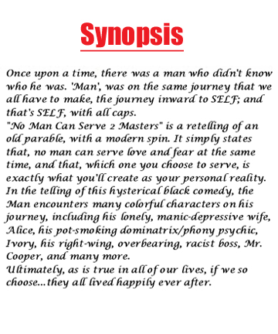

ALL RIGHTS RESERVED

CAST LIST
THE MAN: 40ish, searching for his identity makes most of his life choices out of fear
ALICE: 30- 40, The Man’s wife, deeply hurt, medicated, lives in a fantasy world

IVORY: age open, The man’s dominatrix, a new age, pot smoking, sexy women,
possibly Jamaican
JAKE: 20-40, The man’s occasional sex partner he meets in the park, tough Brooklyn type, possibly Puerto Rican
MR. COOPER: 40-50, The man’s boss, conservative, self righteous, sexist, moral majority
DAVID: 30-40, the man’s co-worker, incredibly handsome, appears to be trustworthy

OLD WOMAN: 40-50, The God figure of the piece, a mother Teresa type, kind and loving also a business woman...
THE BOY: 7-10, the old woman’s grandson, sweet, a bright light, an old soul. Possibly Asian
(the cast should be multi racial)

Sample Scene
ACT 1 SCENE 2
(The set has turned to Ivory’s apartment. As the lights fade up she is spanking the man who is in a diaper. She is in a dominatrix outfit)
IVORY
You’re bad ....bad ...bad ......baby. You know better....Bad boy! Bad baby ....BAD! Ga ga goo goo baby gotta make poo poo..(one last spank ) BAD!!!(they finish Ivory goes over and grabs a glass of wine ) How was that baby?

MAN
It was....good I guess....hard ...real hard.

IVORY
What’s wrong, baby doesn't like it any more?
MAN
No ....I do ...I think ...I do…

IVORY
Hey....I thought you said you like it hard!
MAN
I do, but I think I may be growing out of this, I think …
IVORY
Oh.....I sense your aura changing at a rapid pace baby. Come on baby un-clog those chakras, ground your cord, enter yourself, open up your heart space, and communicate clearly...What’s going on baby?
MAN
Something’s changing Ivory, something’s...
IVORY
Everything’s changing, baby. Every second, every instant. All that was is no more, and all that is , is, and yet all that changed was never real to begin with, and all that’s real is changeless, right? Right. God I’m deep. You know what I think baby? This is a combination night. (pause) Yes, yes, thank you. My spirit guides just confirmed that psychic hit. We’ll combine a little African Violet incense for clarity, and we’ll get the aroma therapy going as well. A little Japanese peppermint green tea oil for communication. How are those chakras coming baby?
MAN
Fine I guess ...
IVORY
Good. Let’s take the field trip within, shall we? (she sits in the lotus position )
MAN
All right ...
IVORY
(deep breathing) I see change on the horizon baby...
MAN
YES!
IVORY
Speak baby, I’m all heart.
MAN
Well, like I said before, I feel like things are…
IVORY
You noticed I said all heart, because it’s only with your heart (slaps his chest) that you can hear. Ears (tweaks his ears) are not for hearing. The heart, that’s where it’s at. Where male and female , yin and yang, receptive and active, all meet and join in sacred matrimony and create balance, peace, and the ability to truly listen. Speak baby ...
MAN
Things just don’t seem very good in my life right now. I feel…
IVORY
Of course they’re not good right now! You’re a Leo right?
MAN
Cancer ...
IVORY
Right....well...there is an important conjunction between Mars and the North Node that takes place in Leo this week. That means the time has come baby for you to be forceful about taking what you want in this world, especially in your love life and career.
MAN
But I’m a Cancer.
IVORY
Right…well....Cancer is the sign right before Leo ...so...it will....it’s close enough. At any rate, in a nut shell, your life is a mess baby, a big poo poo mess! But, this is the time to do something about it baby.
MAN
Yes! I feel that! That’s true ...
IVORY
Of course you feel it baby! We’re all one and we all feel everything. Is not the ocean affected by every ripple? Is not the sun affected by one blocked ray or cloud? Is not the forest affected by one lone tree? Wait! That doesn’t make sense. What am I saying? Keep talking baby. Let it pour out. You’re doing wonderful. I’ll put on some environmental music. What do you prefer? Wind in the trees, rushing rapids, whale songs, and thunder storms? Oh here we go, cool rivers! That will help you go with the flow.
MAN
Well... let’s start with Alice…
IVORY
Oh poo! Just the mention of her name has filled this apartment with negative vibes. Keep talking baby. I’m going to light my sage stick and do a little house clearing. This will insure a positive air .
MAN
Well....I’m …I’m...
IVORY
You’re what baby?
MAN
I’m scared.
IVORY
Of what, baby? Of Alice???
MAN
Everything in my life, not ......
IVORY
Baby focus!! Don’t be rambling all over the place! Stick to one thing at a time!! You said let’s start with Alice, so start!
MAN
Well...I’m not very...happy ...There I said it ...Obviously... or I wouldn’t be here.
IVORY
But baby here is all there is, and if all of there has lead you to here, then rejoice and accept this blissful moment. This moment is eternity. In this sacred moment, this holy instant, we have an obligation, nay, an opportunity, to re-choose happiness, and happiness is a choice baby. Oh ...oh... you know what you need? My special blend of herbs. Blackberry leaves, heather herb, roasted dandelion root, high mallow flowers, horehound and speedwell herbs, poppy flowers, peppermint, sage, and rosemary leaf, lavender flowers and hops seed. I call it serenity tea.
MAN
Wow...all right.
IVORY
While I’m getting the tea , here, hold this rose quartz crystal. It’s for healing wounds of the heart, and if you sit ....oh I believe it’s due east or is it west ....with your head....oh poo ... I just had my apartment Feng Shui’d and I can’t remember which direction to sit in or face or....oh poo I just don’t remember. Oh well, just sit up...SIT UP! Here raise your feet it’s good for circulation and varicose veins.(exits to get tea)
MAN
Well it’s not just Alice either ...it’s everything, work, you, I feel so lost. There are parts of me you don’t know Ivory. Parts of me I don’t even know ...I don’t know.
IVORY
(re-enter) You know what I think baby? Give me your hands...oh yes....breathe deeply ...Yes...that’s good...Exhale ...This is my own free style form of Rai Kai ...(pause) I think you’re unhappy here. I’m going to go out on a limb here. I don’t think this is just about Alice. It’s about work , even me and I believe, no, I’m sure, yes, there are parts of you that neither of us even knows. I’m getting the tarot cards! You have your choice of decks. Albano - waite, angel, aquarian, cat people, deck of destiny, etteilla Egyptian, mother peace round, native American, gong hee fot choy, gypsy witch, Pandora, rolla Nordic, philosopher's stone, tree of life, winds and changes, or zolars astrological. Maybe I should stay away from the astrological ones.
MAN
Oh Ivory you don’t need to do that.
IVORY
You prefer the medicine cards? Why didn’t you say?
MAN
No I...
IVORY
Oh the Runes? You’re a stone man huh?
MAN
No actually I...

IVORY
I get you baby, the crystal oracle.
MAN
UH...no ...I...

IVORY
Ouigi board? Tea leaves....palm reading...
MAN
NO...

IVORY
Well I’m as sure as hell not getting the 8 ball, so the tarot it is. Now, what deck?? I have the albano-waite, angel,

MAN
No, Ivory, please. I need to be going soon. My head is splitting and...
IVORY
Oh poo! Nonsense baby sit. Sit, sit down!! Resume position! (He does)Here put your finger here and here, and pinch lightly. That’s the acupuncture pressure point for head aches. I’ll help open up that crown chakra of yours and then whoosh everything will become much clearer. (She exits) Keep talking baby, you have to purge, purge, come on baby, you have to let it out, have to.

MAN
Well, I want change.

IVORY
(Off stage) Change is all there is baby.

MAN
Well then ...I want it.
IVORY
(Offstage)Then do it baby!

MAN
I don’t know how!....I’m afraid ....My whole life has been nothing but fear and I ..

IVORY
(Off stage) Do you mind if I smoke a joint?
MAN
Marijuana??

IVORY
No parsley! Of course baby, but I prefer weed, reefer, pot, grass, hemp, loco, Mary Jane. Anything but marijuana, dope!

MAN
Sorry I...
IVORY
(re-enters with joint attached to the tit clamp that doubles as a roach clamp) Here we go; you do like tea, right?
MAN
I prefer coffee, Java,

IVORY
COFFEE!?? POO! Well that’s one change you make right now! Coffee’s a drug baby, caffeine? It alters your perception of things. Unless of course you use it as an enema. Then it has tremendous healing properties. I learned that when I was really into colonics, enemas, and all that shit. Well good, see, change isn’t that difficult. You just gave up one of your vices.
MAN
I did?

IVORY
Coffee, and now that you’ve switched to tea, let me caution you about metal pots.(she lights the joint) No,(hit)wrong,(hit)poo poo,(hit)only ceramic.(exhale)The metal can leave deposits in the water and it really throws your system off. Baby can I be straight forward and frank with you?

MAN
Sure, please do.
IVORY
Baby you’re afraid, (hit) afraid of change, (hit) your whole life you’ve been afraid, (hit) you want it,
(hit) but you don’t know how. (exhale)
MAN
Yes, that’s true! How do you do that?
IVORY
It’s that instinct, (hit) that inner voice, (hit) that six sense, (hit) that third eye, (she touches her forehead to indicate third eye and burns it. Coughing) Here, take a hit baby.
MAN
Oh.... I don’t think so.
IVORY
Don’t be such a big baby! It’s God’s plant! This sacred plant has been used by the Indians(hit) Jesus,(hit)the apostles,(hit)Buddha.(hit)Poo, even Clinton.(exhale and coughs)It quiets the mind and lets God’s universal clarity come through, like a great douche, very cleansing.

MAN
I’ll try it. (he does and coughs)

IVORY
Go on baby. Share your pain! You’re doing great. (she starts to change her clothes)

MAN
See, I want change in my life. I want to take a giant step forward.

IVORY
Mother may I?(she cracks herself up)
MAN
What?
IVORY
Mother ...oh forget it! Baby there is no forward.

MAN
There isn’t?
IVORY
(Laughing)No baby! Life isn’t horizontal, it’s vertical! Time, space, all false,(she removes falsies) fake,(she pulls off wig)facades.(she sits to roll another joint)It’s about going within baby, nirvana . You see, for most people, life is like a big old merry go round. They just keep going round and round doing the same old things over and over and over. Well, one day you finally have to get up the courage to say, POO there are more rides in life then this damn merry go round!(Lights the new joint)

MAN
Like??

IVORY
Like ...the tilt a whirl,(hit)the scrambler,(hit)swings,(hit)poo, even a slide.(hit)It doesn’t matter which one’s baby,(exhale) it only matters that you have fun!!

MAN
But what about the bad rides?
IVORY
That’s fear speaking baby, there are no bad ones, or good ones just fun ones. You can’t judge anything baby, remember your commandments?
MAN
So you don’t believe in punishment?
IVORY
Just for recreation! Baby, God doesn’t punish you, he loves you! Hit?(she holds out joint)Oh, the tarot cards! I almost forgot. Which deck? I have the albano-waite..
MAN
NO..

IVORY
SIT!! Sit, sit down! Resume position! Oh... baby I don’t have them right now. I lent all my decks to the pagan priestess up stairs. What she wants with them, I have no idea. She’s really into voodoo and black magic...Freaks me out! To dark for me. Baby you know what I see? Then I’ll let you go.

MAN
Please, tell me.
IVORY
I see birth ...

MAN
(Stands)OH NO ...ALICE??!!

IVORY
Chill baby! Get out of my space! Relax. Sit...SIT!!....(he does)No, not Alice ..you.

MAN
(stands) ME!??
IVORY
Uh,,uh..uh (he sits back down)Yeah you. When I was at this ashram in the Catskills years ago, or was it the Pocono’s, or...unimportant. The point is, my life was messy, poo poo. I was drinking, (hit)sleeping around, (hit)really out of balance.(hit )I had this compulsive behavior.(hit)I didn’t like myself,(exhale)and that’s SELF with all caps. So I went to this ashram and I participated in a re-birthing. I guess it’s similar to what those born again freaks refer to as being born again, except this was legit. It was that re-birthing that is responsible for bringing me here. I wasn’t always this calm,(hit)this balanced, (hit)this attentive,(hit)this ....clear.(hit)It was like the phoenix rising from the ashes.(exhale)

MAN
But how does that apply to..

IVORY
YOU? You’re in one baby!(hit)You’re having contractions,(hit)crowning,(hit)dilated(hit), poo, your water has broken.(exhale)It’s messy ...poo.(she pulls pot seed out of her mouth)You know, a seed, when it grows, doesn’t say, “excuse me Mr. dirt or pardon me miss crab grass, please move aside I need room to grow.” NO! It bust’s through baby! Messy! Poo! Well, the same is true for a baby!(hit)It doesn’t just slide out.(hit)It pushes,(hit)kicks,(hit)screams,(hit. The man stands up) What baby? What’s wrong?? You’re as white as a ghost!
MAN
I have to go.

IVORY
Sure baby! I’m not holding you prisoner or anything ...or am I? ...Oh no, that’s my 5:00. Sorry I get confused. You OK?

MAN
Yeah ...fine.
IVORY
You drive carefully across the bridge. You want one last spanking, baby?
MAN
NO .
IVORY
Yes you do.
MAN
No, thank you, Ivory.

IVORY
DON’T ...DON’T.....you talk back to me! You’re a bad boy!! ...Come here! ....Come here now!
(he does)Bend over....BEND OVER!! Don’t make me ..(he does)You’re bad! Bad, bad baby ...bad (lights fade as she is spanking him. The set turns as carnival music comes up)

