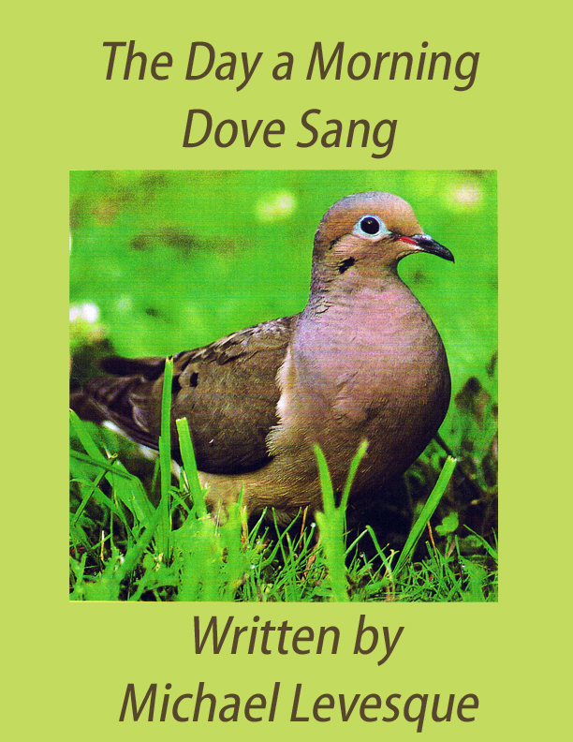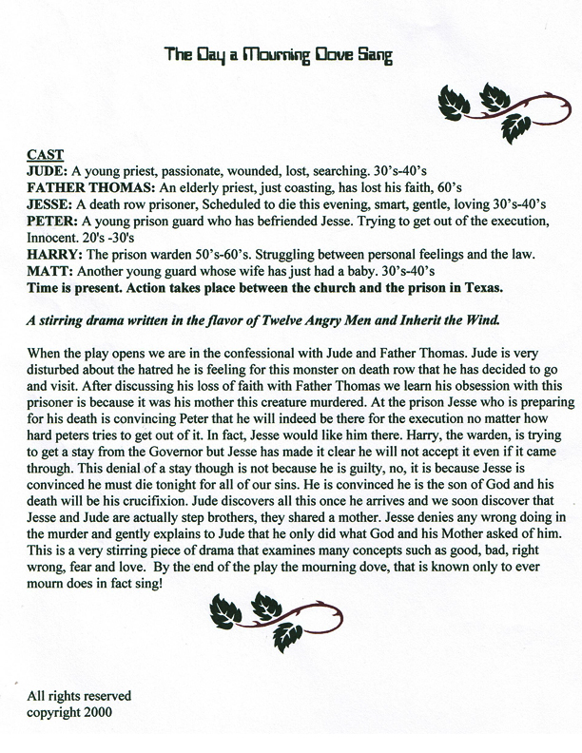
Act One Scene Two
JESSE
(Singing) What so ever you do to the least of my brothers. That you do unto me.
When I was hungry, you gave me to eat, When I was thirsty you gave me to drink
Now enter into the home of my Father. What so ever you do (Peter the guard tries to enter quietly) I’m still here Peter....

PETER
I know you are.

JESSE
Yes.

PETER
I knew you would be.

JESSE
Good.

PETER
Shit Jesse!

JESSE
What?

PETER
It’s only procedure.

JESSE
I know.

PETER
Protocol.

JESSE
Yes.

PETER
We have to do it.

JESSE
I know.

PETER
Right!

JESSE
Ironic, don’t you think?

PETER
What’s that?

JESSE
That the state cares whether I kill myself or not.

PETER
Let’s not get into....

JESSE
I guess in their minds that would rob them of the golden opportunity, and the sublime pleasure of drenching themselves, elbow high, in my blood.

PETER
There’s no blood Mr. Kristi. (he goes to a desk and takes a seat)

JESSE
Metaphorically Peter.

PETER
What?...Oh ..yeah...I get it

JESSE
Oh, Peter, how wonderful!

PETER
What?

JESSE
I’m ecstatic that you’re my officer for the rest of the day.

PETER
Actually, no sir, I’m not.

JESSE
But you’re here.

PETER
Yes, but only until

JESSE
Then you’re my officer.

PETER
But later....

JESSE
There’s only now.

PETER
You’ll get Matt.

JESSE
Oh yes, that.

PETER
No One seems to know where he is today.

JESSE
No one?

PETER
No. He was supposed to be here, with you, full time today.

JESSE
I see.

PETER
I’m just checking in on you until he arrives.

JESSE
Oh that’s too bad.

PETER
What is sir?

JESSE
You won’t be with me today.

PETER
Not full time.

JESSE
I see.

PETER
I’ll do my checks, then you’ll have Matt.

JESSE
Well, that’s quite all right. I care just as much for Matt as I do for you. (pause)This really is the ultimate display of control, don’t you think?

PETER
What’s that sir?

JESSE
You!

PETER
ME??

JESSE
Them.

PETER
OH...

JESSE
Making sure I don’t kill myself so they can have the honor of doing it themselves. Don’t you think that’s the ultimate display of control?

PETER
I don’t really think about it Mr. Kristi, to tell you the truth....or try not to at least...

JESSE
Yes. ..One would hope not, yes?

PETER
Yes.

JESSE
I mean, how could one, right?

PETER
Right....

JESSE
Think about it, I mean....

PETER
Yes.

JESSE
(pause) You will be there, won’t you Peter?

~ PETER
…actually...

JESSE
Yes?

PETER
No sir...

JESSE
No?

PETER
I won’t be....

JESSE
Oh Peter...

PETER
I’m sorry

JESSE
Don’t be.

PETER
You’re angry.

JESSE
Disappointed.

PETER
Sorry.

JESSE
I was hoping you would be one of my personal escorts,
PETER
I know...

JESSE
…strap down crew, left leg or something.

PETER
Yes...

JESSE
You know very well you’re one of my favorites.

PETER
I know.

JESSE
What if I don’t know the other guys?

PETER
You’ll know some of them sir...

JESSE
I will?

PETER
Yes.

JESSE
But not like I know you...

PETER
No.

JESSE
We’ve been through so much together you and I....

PETER
I know sir....

JESSE
Yes.

PETER
And believe it or not, you’re one of my favorites as well....

JESSE
Then why would you deny me the company of your sincere friendship at one of my most triumphant moments?

PETER
Deny?

JESSE
Yes.

PETER
NO!

JESSE
Peter.

PETER
I have to go...

JESSE
No.

PETER
Yes, I’ll be back in

JESSE
Fifteen minutes.

PETER
Yes.

JESSE
Yes, I know.

PETER/JESSE(TOGETHER)
Suicide watch.

PETER
Yes sir.(He starts to exit)

JESSE
See you soon! (sings) What so ever you do to the least of my brothers....

PETER
Mr. Kristi?

JESSE
Yes Peter?

PETER
I.. .1....

JESSE
I thought you had left already.

PETER
No.

JESSE
What is it?

PETER
I just want you to know....

JESSE
Yes?

PETER
I told them I couldn’t do it

JESSE
I know.

PETER
You know?

JESSE
Yes.

PETER
I just wanted you to know that

JESSE
Thank you.

PETER
I didn’t want to lie to you sir

JESSE
No...

PETER
No.

JESSE
It’s your job Peter....

PETER
I know.

JESSE
That’s all.

PETER
That’s all?

JESSE
Yes.

PETER
But..

JESSE
But what?

PETER
I don’t know if I can ever do that again ..sir....

JESSE
I know.

PETER
and that’s scaring me....

JESSE
Yes...
PETER
I mean what would I do?

JESSE
You will know.

PETER
I’ll know?

JESSE
Yes.

PETER
You think?

JESSE
I know.

PETER
Oh (Pause) I was thinking about what you said....

JESSE
What was that?

PETER
You said...

JESSE
Yes, go on

PETER
You said, “For as long as I stay here and guard you, I am actually imprisoning myself.”

JESSE
I said that prisoner and guard are one

PETER
Yes...

JESSE
They are both the belief in evil and punishment. They both are imprisoned.

PETER
Yes.... I’m sorry.

JESSE
Why?
PETER
Shit, I know there are probably better things you’d like to be doing your last day, besides listening to me ramble on like this

JESSE
You know that?

PETER
I mean after today What’s it matter to you right?

JESSE
If you say so

PETER
I just did.

JESSE
So, you did.

PETER
(pause) I guess I just wanted you to know you were a big help in starting to get me to think that maybe I should be doing something else with my life other than this. You know?

JESSE
Yes.

PETER
Shit!

JESSE
What?

PETER
Nothing.

JESSE
That’s so wonderful Peter.

PETER
Is it?

JESSE
Isn’t it?

PETER
I guess...

JESSE
Sure it is. (pause) What else do you think you would do?

PETER
I don’t know.

JESSE
You know.

PETER
I don’t care.

JESSE
Sure you do.

PETER
Hey!

JESSE
What?

PETER
Do you get what I’m telling you?

JESSE
Yes, I believe I do.

PETER
I don’t think you do!

JESSE
You don’t?

PETER
I can’t do this!

JESSE
No.

PETER
Do you get that?

JESSE
Yes...

PETER
I have worked here almost twenty years of my life

JESSE
Yes...
PETER
and I can’t begin to tell you how many times I have taken that long walk down that flicking corridor to that...that...

JESSE
Cold....

PETER
...room...and never...

JESSE
Ever...

PETER
Yes, not once have I ever given a second thought,

JESSE
Yes...

PETER
...let alone not be able to do it...

JESSE
No...

PETER
NO!...Not Once!

JESSE
No.

PETER
Now do you get it??

JESSE
Yes...

PETER
Huh? Not once....

JESSE
No...

PETER
until now

JESSE
Yes...

PETER
Ever!

JESSE
Never..

PETER
EVER!

JESSE
Shhh...it’s all right Peter...

PETER
IT IS NOT ALL RIGHT, GOD DAMN IT! (pause) Jesse, do you realize you’ll be dead in less than twelve hours? Do you get that?

JESSE
Yes.

PETER
Do you??

JESSE
It doesn’t mean anything...

PETER
What?

JESSE
nothing

PETER
Nothing?

JESSE
Yes. Do you understand me?

PETER
I don’t know.

JESSE
It doesn’t mean a thing...

PETER
No?

JESSE
No, nothing....
PETER
Yes...

JESSE
Never forget that

PETER
No...

JESSE
All right?

PETER
Yes.

JESSE
Good.

PETER
I don’t know who or what you are, but I

JESSE
No. You don’t know who or what you are Peter.

PETER
What?

JESSE
You’ve denied it.... forgotten....

PETER
Forgotten?

JESSE
That’s the truth....

PETER
The truth?

JESSE
Yes.

PETER
It is?

JESSE
Yes.

PETER
Yes....

JESSE
AMEN. (the warden enters)

