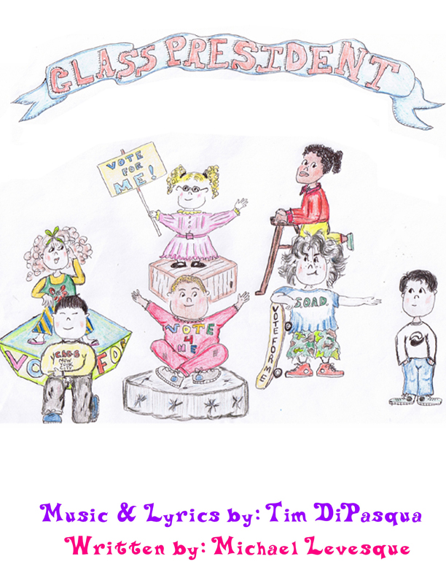
Cast List
Tiffany Nichole Gold: A 10 year old. A self centered conceited pretty girl. She used to do beauty pageants.
Diego Currais III: A 10 year old Cuban boy. Very smart but also very angry at the way his class mates have treated him for being “different”.
Pamela Lee Nelson: A 10 year old girl. She is smart, articulate and a little nerdy, always the brain in the room.
Buddy Babcock:: A 10 year old boy. Bud is the bully of the school but deep down has a heart of gold.
Larry P. Williamsburg: A 10 year old boy. Larry is sick and possibly terminal. He is an average boy from middle America.
The Teacher: Any sex, age or race. The teacher of the class.
Time: Now
Place: Elementary school

Sample Script
TEACHER
(The teacher enters the class room or auditorium. We hear a vamp of the opening number begin.) Alright class settle down, settle down. Today is a very special day. Today we vote for class president. We have five distinguished students all hoping to win your votes. So without wasting anymore time let me introduce our five nominees. Tiffany Nichole Gold. Diego Currias III, Buddy Babcock, Pamela Lee Nelson, and Larry P. Williamsburg. We will be hearing from each candidate about why you should vote for them so….let’s begin!
Opening song

Vote for Me

PAM
Vote for me, I want to be class president.
Please pick me. I’ll be the best class president.
Can’t you see? The choice is clearly evident.
I’m the one that you can count on. Vote for Me!
I know you didn’t ask for it, but in my own opinion
to be able to vote in elemen-try school is cool
so vote for me you’ll be really glad you did.

I don’t know about you, but I’m getting sick and tired of having recess in our tiny, over-crowded playground. When there’s a perfectly good playing area in the vacant lot just next door on the other side of that wall. If elected, I promise that my first order of business would be to convince our school officials to spend the money and buy that lot and build a playing field we can be proud of. I say “Principal Kruzinski, tear down that wall!!!!!
Vote for me!
BUD
I agree. I think that you’d be excellent.
Next to me, you’d make a great vice-president.
Stick with me you’ll make me look intelligent.
I’m the one that you can count on. Vote for me.

I may not have a 4.0 and I know I may not be book- smart, but I’m street smart, and street tough, I know how to get things done
Cause I m following in the footsteps of last year’s president Ricky Balestreri, a tough fighter who knows how kick butt and shake things up. If elected I promise to clean this place up and bring this place back to order, just like Ricky did.

DIEGO
Bud, I served with Ricky Balestreri, Ricky Balestreri is a friend of mine, and you Buddy Babcock are no Ricky Balestreri.
PAM
Quick…. spell potato.

Bud
P - 0 - t - a - t - o - e ????

DIEGO
See what I mean?

I would be a fair and balanced president.
I need to be………

TIFFANY
A Legal U.S. resident

DIEGO
Si!!! that’s me. A strong Latino president
I’m the one that you can count on. Vote for me!

in Spanish: You’ve got nothing to fear but fear itself.
in English: I said you’ve got nothing to fear but fear itself. And maybe the cafeteria meatloaf.

TIFFANY
Vote for me, I’m cute but also competent.
Vote for me, I’ll take it as a compliment.
Who, but me, would be the best to represent?
I’m the one that you can count on. Vote for me!

I want to build a kindler, gentler and prettier school. And I think
I can do it, but I need your help. Ask not what Baden elementary school can do for you, but what you can do for Baden Elementary. Go for the gold. Tiffany Gold!.

Larry:
We need somebody that we believe in.
We need somebody to stand up strong.
So let me speak now to the student body
It takes a litte bit more then getting on the floor
to dance and sing a song full of promises.

All
Vote for me

Larry
Don't forget the little guy!

All:
I'll show you how the money's spent
Trust in me.

Larry:
Remember, Always look them in the eye!

All:
I'll clean up your enviornment
Wait and see!

Larry:
They'll know if you telling them a lie!
All:
I'm the one that you can count on

Vote for Me! Just give me one more second and
answer this one question:
Are you better off now then you were a year ago?
No? Then vote for me, you’ll be really glad you did.

