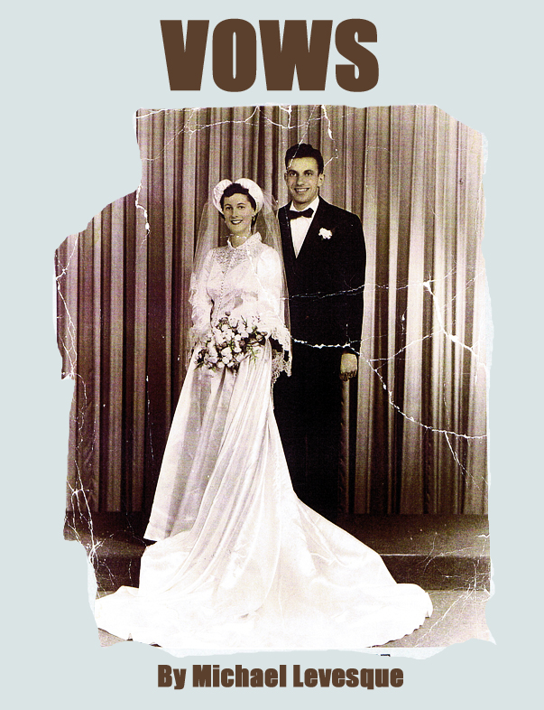
All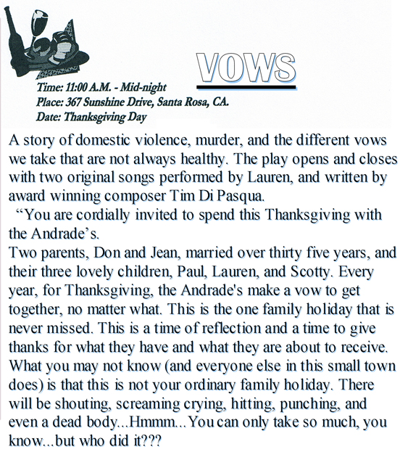
All Rights Reserved
VOWS
CAST LIST
____________________________________________________________________________________________________________________________________________________________________________

PERRY: Lover to Lauren Andrade (mid 30’s to early 40’s), “together”, level headed, frustrated with Lauren’s emotional availability.

LAUREN ANDRADE: (mid 30’s to early 40’s), a lesbian, the middle child of the Andrade family, a cabaret singer, living in New York, uses her music to escape the pain.
PAUL ANDRADE: The oldest of the three children, (early 40’s to mid 40’s) on his third marriage; (the past two were abusive). Hot tempered, angry, a hurt man, married to Rachel. An artist. His father’s favorite.
RACHEL ANDRADE: (mid 30’s to mid 40’s) Paul’s wife, kind of brassy, white trash, used to be beautiful, but the strain of the marriage is starting to take a toll.
DON ANDRADE: (60’s) The father of the family, an alcoholic, abusive, violent, self righteous, and crude.

JEAN ANDRADE: (60’s) The mother of the family, meek, abused, scared, was once a beautiful vibrant woman, loved Don very much.
SCOTT ANDRADE: (Early 30’s to mid 30’s), the youngest of the three children, an alcoholic unemployed, a trouble maker, his mother’s favorite, a tortured poet. Should be physically beautiful.

ANNE: (The Mouth, 50’s) Neighbor to the Andrade’s, has lived next to them almost all of their lives. She knows what goes on. She is Jean’s best friend, fun loving, nosy, and is one of the only people who don’t let Don bother her.

OFFICER TONY WILCOX: (mid 30’s- mid 40’s) He is the town police officer, a little slow, but kind and sweet.

SAMPLE SCENE
PAUL
What a trip. I can’t believe you wrote a song about our fucked up parents.
LAUREN
We all do what we have to do Paul.
SCOTTY
So Paul, how’s it feel to know it was all your fault? Mom never would have married that creature if she didn’t have you stuck in her womb.
LAUREN
SCOTTY!

PAUL
(To Scotty) Shut up!
SCOTT
Now I don’t feel so bad about ever calling you a bastard.
PAUL
I’m not a bastard asshole...A bastard is when....
LAUREN
Paul, don’t bite the bait.
PAUL
Right. (He starts to count but calmly this time) 1.2.3. (Lauren speaks over Paul’s counting)
LAUREN
Scotty, I can’t get over how wonderful your poem is. I’d like to use it for a song.
PAUL
(This stops his counting) Oh great…
SCOTT
( to Lauren)WHAT??(staring at her)
PAUL
She said she’d like….
SCOTT
Fine! Keep it if you want.
PAUL
What about your little childhood sweetheart, huh? …Kitty…Katy
LAUREN
Kathy.
PAUL
Right, Kathy.
SCOTT
What about her? What?? We’ll see. Just keep it Lauren. Keep the fucking thing.
LAUREN
I’ll just copy it down. You keep it.
SCOTT
What ever. I’m going to bed. (Scott starts to exit)
PAUL
Do you need me to climb in with tonight if you get scared??(this stops Scott)

LAUREN
Climb in with him?

PAUL
Yeah, you don’t remember that do you little brother?
LAUREN
What the fuck are you saying Paul? This isn’t some new piece of family dysfunction we’ve decided to break our silence about is it?
PAUL
God no, Lauren....
LAUREN
Well, you never know around here...
PAUL
When we were small I used to climb into Scotty’s bed whenever...he was...beating her up...I used to lay there and cover his ears praying that he wouldn’t wake up and hear them. And now looking at the expression on his face, I think it must have worked. I never knew if you knew that I used to do that until now.
LAUREN
Paul...Scotty this is the first time you’ve heard of this? My God...Paul, that is....so...sweet...and you never knew?
SCOTT
He would climb in, and get really close to my body, I would feel his chest moving from breathing really fast. I could tell that he had been crying... there was a whimper in his breath...sometimes I could even feel my back getting moistened...wet, from his tears... Then I would feel his hands... they always seemed so enormous to me back then... big...and I remember I would imagine, right when he would place them over my ears…like this...I would think...he’s powerful...strong....I bet he could beat daddy...He could make HIM stop! I use to wonder why you were trying to help me and not mommy... and then I would say, silently, so you wouldn’t know that I knew...that’s my Paul...I’m taken care of him ...
LAUREN
So you knew....
PAUL
(turns back) Why didn’t you ever say anything?
SCOTT
I always thought up until five minutes ago...I was the one helping you...and I decided long ago I didn’t need any thanks from you...I knew you needed it...I knew how terrified you were...I would hear you weeping and praying up there in that top bunk...and I would say to myself I am going to count to ten and if he’s still hitting her before I get to ten, I know Paul will be down here... and you would be...I knew you had to hold me and I knew you had to know you were protecting someone...and now, standing here, I see that you were...that you are...Thanks Paul...
PAUL
I love you bro, sis. I love you guys. (they all hug. Scott breaks away and starts to exit) Night little brother.
SCOTT
Good night Paul, Lauren. (he exits)
LAUREN
Goodnight. Are you all right?
PAUL
Yeah. You?

LAUREN
OH SHIT!!

PAUL
What?
LAUREN
I was supposed to call Perry.
PAUL
You still can. I’m sure she’s still awake.
LAUREN
I’ll wait till morning.
PAUL
I’m happy for you Lauren. (he starts to exit) You know…you and your… (pause)
LAUREN
Partner? YEAH…Thanks. You going to bed?

PAUL
Yep. (He turns to exit and then stops) Do you think everyone else is as screwed up as we are?

LAUREN
I don’t know.
PAUL
I bet not.

LAUREN
I bet you’re right.

PAUL
Oh well…Good night. You staying up?
LAUREN
Just for a few seconds. Night. (He exits. She goes to the piano and starts to pick out a melody. Then she gets up and turns off the light as she heads upstairs. BLACKOUT. In the blackout we hear the fighting begin. Don is very violent. We hear her screaming, as she is screaming we see the shadow of someone come down the stairs and pick up the rifle and run upstairs. We hear a gun shot. Jean screams.)

