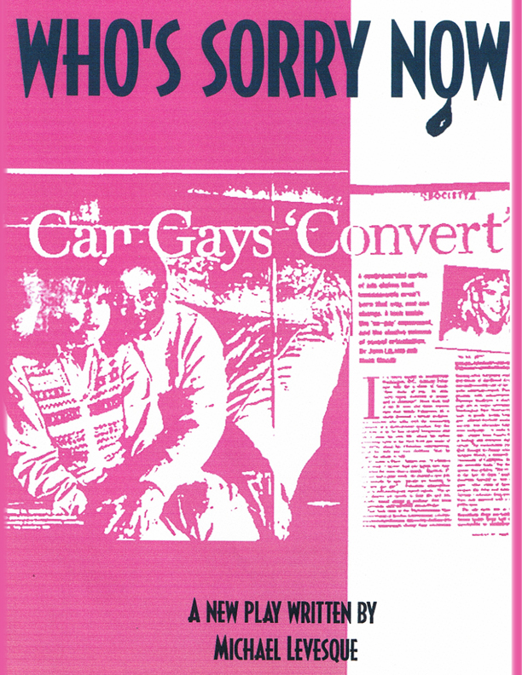
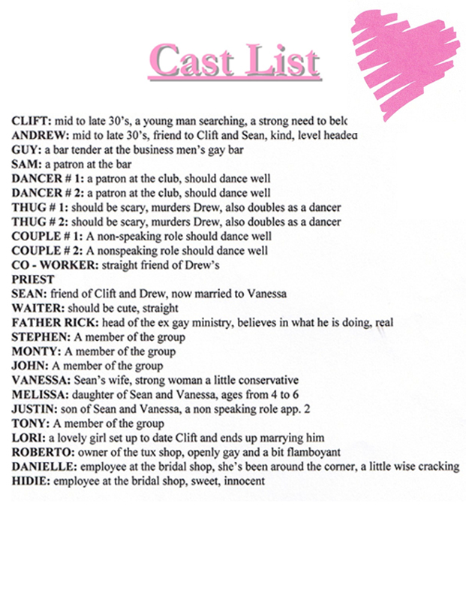
All Rights Reserved
ACT 2 SCENE 4
The Truth
(A lamp goes on, lights come up a little, and Sean is sitting at the table writing a letter crying Clift comes in)

CLIFT
Sean... Sean are you alright?

SEAN
Yes I’m fine, what are you doing up?

CLIFT
You know how it is, the night before, I couldn’t sleep so I came down for a snack. What’s going on? Sean...what’s going on?
SEAN
It’s nothing Clift.
CLIFT
Are you and V. having trouble again?
SEAN
Again?

CLIFT
Come on I’m not blind, I can tell things have been tense for awhile.
SEAN
Its fine...um...things are...um... things are ...fine. No, no trouble, not really.
CLIFT
Not really? What does that mean, not really? Are you or not?
SEAN
Can I ask you a personal question?
CLIFT
Of course you can.

SEAN
Have you had sex with Lori?
CLIFT
Why ... why do you ask that?
SEAN
Have you?
CLIFT
You know how we both feel about that, once our relationship is consummated tomorrow night, we’ll make love with Gods blessing, as it’s meant to be.

SEAN
Are you nervous?
CLIFT
No! Why do ask, what is this about?
SEAN
Are you sure you can?
CLIFT
Of course... Sean...why do you...what...of course I can.

SEAN
Positive?
CLIFT
This is a ridiculous conversation, I’m going back to bed...
SEAN
Because I can’t... (he starts to cry) I can’t ...make love to Vanessa

CLIFT
Sean is that what this is all about...shhh...shhhh... Sean look at me, It’s OK. these things happen to all of us, it doesn’t mean anything.
SEAN
It does mean something Clift, it does.
CLIFT
This happens to everyone. My God, you have guests running your house, all the work you two have done, the kids, I don’t know if I could perform under these conditions either. Sean V. loves you deeply, I’m sure she understands. You’ve been under allot of pressure, you’ll see, once tomorrow is over all the passion will come rushing back in. Trust me.
SEAN
(Crying) There won’t be a tomorrow with Vanessa and me.
CLIFT
What are you talking about Sean, talk to me

SEAN
I can’t do it anymore
CLIFT
Did V. ask you for a divorce?

SEAN
No...but I can’t do it anymore...I just can’t do it.
CLIFT
You’re making this into a huge problem.
SEAN
It is a huge problem!
CLIFT
My God there are many ways to work these things out ....come on be realistic here. What about the kids?

SEAN
I know I feel terrible, what should I do about them? I love them so much.
CLIFT
You should go back to bed, get a good night sleep, and on the way up tuck your kids in and kiss your lovely wife goodnight. Now come on, get yourself together, Sean...SEAN.
SEAN
I’m sitting here while my beautiful wife is sleeping in the bed we’ve shared for the past five years and two amazing children are sleeping right above our heads here , and my best friends wedding is tomorrow and all I want to do is make love with him ....you .
CLIFT
WHAT??
SEAN
Clift I’m so sorry, please forgive me.
CLIFT
What are you doing, you’re just having a moment.
SEAN
Yes a moment of truth.

CLIFT
No!
SEAN
Yes.

CLIFT
Be strong Sean.

SEAN
Clift listen to me, ever since I saw you at the funeral, it all came back.

CLIFT
What?
SEAN
Clift, I’ve always loved you.
CLIFT
You loved Drew.
SEAN
I only went with Drew then because I knew how much you wanted him, I couldn’t bear it. Then came all the drugs and the sex and it wasn’t me, it just wasn’t me.
CLIFT
And now you’re saying it is?
SEAN
No , but I was so lost , I didn’t know where to turn and the next thing I knew I was here and it worked , it really seemed to work .

CLIFT
And it still can.
SEAN
No!!

CLIFT
WHY!!
SEAN
It’s a lie...my lie....it’s not the truth.

CLIFT
Your truth!!

SEAN
Exactly, what other truth is there?
CLIFT
God’s truth.
SEAN
It’s the same thing...
CLIFT
No, that’s the devil speaking Sean.
SEAN
No, it’s God speaking Clift, it’s always been God speaking to me, I just kept ignoring it. First with Drew, then the drugs and sex and then my wife and kids and now this, your wedding.
CLIFT
What about my wedding?
SEAN
I can’t be here.
CLIFT
What?
SEAN
I’m sorry Clift, but I can’t be there.

CLIFT
You’re just not coming?
SEAN
When you came down tonight , I was crying because I can’t figure out how to say good-bye to my wife and children ( he holds up the letter ) How can I explain to them that my life with them has been a total lie ?
CLIFT
What are you saying?

SEAN
I’m leaving Clift, I’m leaving tonight.

CLIFT
No you just can’t run out on me again, you’re my best man for Christ sake.

SEAN
This isn’t about you Clift, I’m not running out on you.
CLIFT
Yes you are, and your wife and kids....

SEAN
I have to get away, I have to be myself.

CLIFT
I thought that’s what this was about, I thought that’s why you came to Seattle .

SEAN
It was.

CLIFT
So are you going to spend your whole life running out on people who need you, who depend on you, searching for something you may never find?
SEAN
I don’t know...no... no... I’ve found it.
CLIFT
How is going back to all the drugs and the sex and the homosexual lifestyle finding it, how di
SEAN
I’m not going back to that, I’m me, me. I don’t do drugs , I don’t want anonymous sex , I want exactly what I have right now except I want a man in that bed Clift , a man . I’m gay.
CLIFT
Ex gay!
SEAN
Gay Clift, gay, and I can’t deny it anymore.
CLIFT
Stop it, stop it!
SEAN
What’s wrong Clift, truth getting to you?
CLIFT
I’m going to get V.
SEAN
No Clift, please don’t. Please don’t Clift, please.
CLIFT
What do you want me to do? (now crying)
SEAN
Nothing Clift, do what you’re doing, if you’re happy.

CLIFT
(pause) How do you know if this is right?

SEAN
We know Clift. We all know. Can you honestly stand there look right into my eyes and tell me that you’ve never, ever, heard that sweet loving voice of Christ saying it’s OK. I love you; I love you just the way you are.

CLIFT
I don’t know, I don’t know damn you!! Damn you how could you do this to me?

SEAN
What am I doing to you?
CLIFT
Making me confused, mixing me up. Jesus Christ tomorrow’s my wedding I love Lori, I love her.
SEAN
Then marry her.

CLIFT
But... I... I ...I want you there.

SEAN
Why?
CLIFT
I need you there...I’m doing this because of you. You’re the one , you’re the reason I’m healed , you’re the reason I’m marrying Lori . (Vanessa comes down in robe and hears them and sits on the stairs like Sean and Clift did earlier)
SEAN
I’m sorry Clift if I helped lead you astray , I’m truly sorry , but it’s it right you’ll know it .
CLIFT
You didn’t! How? Why are you doing this, why?
SEAN
Clift, ever since you came here, I haven’t had a peaceful night sleep. At first I could pretend, I could still make love with my wife, but after awhile it was you Clift. I would conjure up your face, your lips, just like I used to do with Drew. Then I just couldn’t even touch her anymore, the pain of what I was denying myself became to great. Then the dreams started, it was you every night coming to me in my sleep. Then the days, seeing you sober and happy made me love you even more.

CLIFT
Oh Sean...
SEAN
Then Lori came along.

CLIFT
You introduced us.
SEAN
Just like I introduced Drew.
CLIFT
Why?
SEAN
I wanted to see you happy, that’s all I ever wanted for you. when watching you with Lori I thought I could be happy for you, I thought I could be happy knowing we could still be close to each other .I thought I was healed, and now sitting here watching you is like looking in a mirror five years ago, but then I realized I am healed and I can’t spend anymore time denying who I am and what I want.
CLIFT
Don’t leave me again, please don’t leave me.
SEAN
(goes to Clift and puts his arms around him) I love you Clift, I love you so much.
CLIFT
I love you too. (Sean starts to kiss him things start to get very passionate) Stop it this can’t happen.
SEAN
Come away with me Clift.
CLIFT
I can’t.

SEAN
Yes you can, come we’ll leave right now, right through that door. It’s the door to freedom Clift you know it.
CLIFT
No, stop it Sean, stop it.
SEAN
Come on.
CLIFT
Stop!! (we see a light come on up stairs Vanessa doesn’t know what to do)
LORI’S VOICE
Hello Clift?
CLIFT
Yes..?
LORI’S VOICE
You OK? Honey are you alright? (Clift scrambles to pick up his robe) Honey??
CLIFT
Yes dear I’m fine...thank you.

LORI’S VOICE
Well don’t stay up to late, I don’t want a sleepy groom on my honeymoon.
CLIFT
I won’t...dear...goodnight.
LORI’S VOICE
I Love you. (pause) Clift?
CLIFT
...I love you too ...dear.

SEAN
Well this is it then?
CLIFT
Don’t say that.
SEAN
What are you saying Clift?
CLIFT
We thought it was it once before as well.
SEAN
Don’t do this to her Clift.
CLIFT
I’m doing this for me.

SEAN
Don’t lie to yourself.
CLIFT
S top it, please Sean.

SEAN
Please tell them...I’ll be in touch.
CLIFT
Sean... (crying) please I’m begging you ...the wedding.
SEAN
How can you expect me to do this?

CLIFT
You owe me Sean, please ...you are my best man ...please....
SEAN
You always did have a way of getting what you want.

CLIFT
You think so, huh?
SEAN
Al right I’ll come. (Vanessa gets up to exit)

CLIFT
Thank you.
SEAN
But I’m going to leave after the wedding. (This stops V. to listen a little bit more) I’ll need you to explain it to Vanessa and the kids, or at least V. . . I’ll write and get in touch as soon as I’m settled. Tell her she never has to worry about those, my kids...
CLIFT
Sean don’t wait four years or until another funeral.
SEAN
I won’t, I promise as soon as I’m settled. Tell her how much I love her...and...um...thank you. (V. exits)
CLIFT
I...um....I....about earlier ....Sean
SEAN
Look I’m sorry ...I just lost myself.
CLIFT
No...um...thank you...I love you.
SEAN
I love you too....now you better get some sleep ...honeymoon and all.
CLIFT
You’ll be there, yes?
SEAN
At the honeymoon, I wish...yes I’ll be there.
CLIFT
Promise?

SEAN
I do. (Blackout, wedding music starts, then two spots come up one on Lori on the stairs.)
LORI
I do. (then on Clift on stage)
CLIFT
I do. (then more wedding music as the set is set then...)

