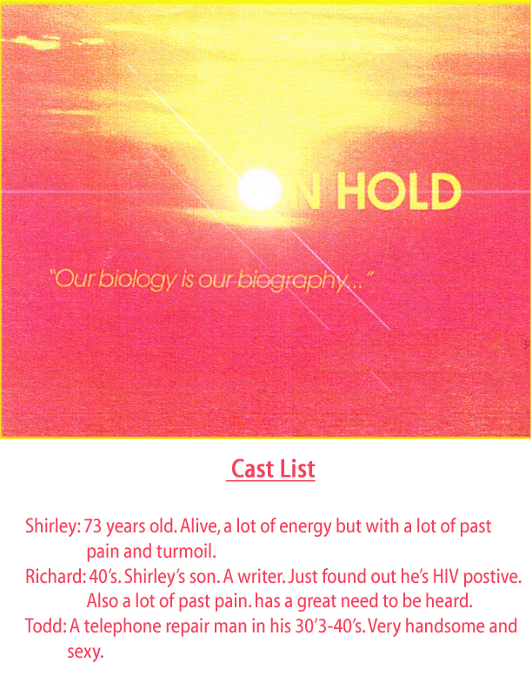

All Rights Reserved
Sample Scene

RICHARD
(pause) So do you want coffee?

SHIRLEY
Let me do that.
RICHARD
I got it.

SHIRLEY
I don’t mind....

RICHARD
I’m fine. Just sit. (she does) How much do you want?

SHIRLEY
Well honey I know it isn’t good for me, but I just can’t give up caffeine. I get these terrible headaches, like migraines, every time I try. You know the kind that starts at the back of your neck and travels right up behind your eyes. It’s excruciating. You remember me and my migraines don’t you? Dear God, I would be in bed sick all weekend long. Do you remember that? Of course you do. How could you not? You remember everything.

RICHARD
So you don’t want any?

SHIRLEY
What?

RICHARD
Coffee.

SHIRLEY
You don’t have any do you?

RICHARD
Not with caffeine I don’t. Mom, why didn’t you say something? I would have bought some but I thought you had given it up. Sorry.

SHIRLEY
Well I tried, but it was horrible. The pounding...Oh...I thought I was going to die.

RICHARD
That’s exactly why you need to give it up.

SHIRLEY
To get headaches, no thank you. What sense does that make? I spent most of my life with a headache I don’t need any more.

RICHARD
You’re only getting the headaches because that’s part of the withdrawals from the caffeine.

SHIRLEY
Withdrawals! You make it sound like a drug or something.

RICHARD
It is.

SHIRLEY
Oh you kids make me laugh. Just because you all smoke your dope and do all your drugs, that you know I don’t approve of, you try to make me feel guilty about a little caffeine.
RICHARD
I’m not trying to make you feel guilty. I’m trying to get an answer out of you. Do you want any or not?

SHIRLEY
No, I’m alright. I can do without my drugs for one morning.

RICHARD
All right.(he makes coffee)

SHIRLEY
You know, looking back on it, I think it was sub-conscious or self induced in a way. I only got those migraines on the weekends. During the week when I was working I was fine. It was only on the weekends when I had to deal with all your father’s crap, that I got those damn headaches.

RICHARD
Mom....

SHIRLEY
Oh, I know, I won’t get into all of that now; I know how you hate hearing it.

RICHARD
Thank you

SHIRLEY
All I’m saying is maybe there’s some truth to what you always say. Oh what is it? Your… oh…your biography is our biology...oh no, no, no...the other way around...our biology is our biography…What ever it is, I’ve been trying to remember that more often, especially when I’m not feeling very well. That’s all. Nothing more...I promise no more talk about you know who.

RICHARD
Yes... so... (clears his throat) How’d you sleep?

SHIRLEY
Fine, you sweetheart?

RICHARD
umm...good.

SHIRLEY
You were up early.

RICHARD
Yes.

SHIRLEY
You couldn’t sleep?

RICHARD
There’s a lot on my mind.

SHIRLEY
Work or personal?

RICHARD
Personal.

SHIRLEY
(she stands and looks at the view) Oh look at this! I can’t get over how gorgeous this is!

RICHARD
(goes to her) I’m glad you like it mom.

SHIRLEY
Like it, I love it! Oh dear this is so wonderful. Thank you for this. It’s truly beautiful.
(she kisses him)

RICHARD
I’m hoping we’ll be able to spend some quality time together this weekend.

SHIRLEY
Every time together with you is quality time. You’re such a good kid. (she starts to go to
the kitchen)

RICHARD
I’ll get that.

SHIRLEY
Get what?

RICHARD
My coffee.

SHIRLEY
Oh all right.(she starts going through the cupboards frantically)

RICHARD
What are you looking for?

SHIRLEY
A kettle...or a pan.. .or something...

RICHARD
I’ll make breakfast mom.

SHIRLEY
Fine but I want to boil some water first, I have some tea bags in my suit case.

RICHARD
I thought you were going without today mom.

SHIRLEY
Its tea dear, not coffee.

RICHARD
That’s worse. It has even more caffeine in it.

SHIRLEY
I don’t think so dear.
RICHARD
No I’m telling you it does. Here let me. (he starts the water she exits to the bedroom to get her tea bag) Unless it’s herbal.

SHIRLEY
I think it is.

RICHARD
What kind is it?

SHIRLEY
Oh shit! SHITI

RICHARD
What’s wrong?

SHIRLEY
I can’t find it. Damn it!

RICHARD
Where’d you put it?

SHIRLEY
If I knew that, I’d find it wouldn’t I? I thought I put it in the front zipper of my suitcase. Oh... I swear I’m getting Alzheimer’s.

RICHARD
You’re not getting Alzheimer’s mom.

SHIRLEY
What dear?

RICHARD
You’re not getting Alzheimer’s.

SHIRLEY
Maybe it’s in my purse.(she enters) Where’s my purse? Richard? RICHARD!!!

RICHARD
What?

SHIRLEY
My purse!!! Did I lose it in the cab? Jesus, I’m losing my mind.

RICHARD
You didn’t lose it in the cab. Check the chair.

SHIRLEY
(she does) Oh thank God. (she dumps her purse)

RICHARD
Is it there?

SHIRLEY
Yes, I found the purse, but my tea bags aren’t here. Damn it.

RICHARD
Mom have some decaf, please

SHIRLEY
I don’t want decaf, I want my tea! Richard, help me!

RICHARD
What do you want me to do?

SHIRLEY
Help me find it!!

RICHARD
Mom, you’re an addict face it.

SHIRLEY
I’m not an addict, I’m losing my mind!

RICHARD
Stop affirming that mom.

SHIRLEY
Well I’m not young any more sweetheart.

RICHARD
STOP! Mom, STOP!!(She does) Take a breath. (she does)

SHIRLEY
My make up case! (she runs out to the bathroom)

RICHARD
HELP! (he goes to the kitchen to get her hot water)

SHIRLEY
Here it is! (entering) Oh thank God I found it.

RICHARD
Do you feel better?

SHIRLEY
YES! I’m sorry. I’ve been so forgetful lately. Richard, why didn’t you boil the water?

RICHARD
It’s done mom. Here, give me the tea bag. Now sit and relax mom.(she does) Roll me a joint. 11mm Earl Grey, what kind of an herb is that?

SHIRLEY
I don’t remember.

RICHARD
How’s that joint coming?
SHIRLEY
Very funny. It’s bad enough you do drugs you don’t have to joke about them Richard. (he brings her tea)

RICHARD
Here you go mom a nice calming cup of earl grey.

SHIRLEY
Thanks sweetheart. (the first calm moment) Oh this is nice.

RICHARD
I’m glad you like it. I hope we can just relax and have a great weekend.

SHIRLEY
Oh me too sweetheart, me too.

RICHARD
Did you get a look at the beach yet?

SHIRLEY
I’m looking at it right now. It’s beautiful. Though it looks like it’s getting a little overcast, but it’s still lovely.

RICHARD
I mean get a real look at it you know. Really look at it?

SHIRLEY
Well honey how could I have done that? We got in late last night, and I just got up, you’ve seen everything I’ve done since I’ve been here dear.

RICHARD
Oh God I hope not, that could be gross. (he laughs)

SHIRLEY
Thanks a lot.

RICHARD
Just kidding.

SHIRLEY
Always the jokester, just like your father.

RICHARD
(pause)I’m sorry, you’re right, of course you haven’t. So would you like to get a better
look later on?

SHIRLEY
Of course I would, that’s why I’m here. (pause) Are you all right sweetheart?

RICHARD
Yeah.,.yes...I’m…fine.

SHIRLEY
Are you sure?

RICHARD
Yeah...positive.

SHTRLEY
Are things fine with Jason?

RICHARD
Yeah...oh yeah…yeah, absolutely.

SHIRLEY
You don’t sound too sure of yourself.

RICHARD
No, no, I am.... things are great with Jason. Umm…he’s ...he’s been very supportive. Especially now, things are just…

SHIRLEY
(she rises. Looking straight out.) Oh! Would you look at the sun...Look at it... (laughs) It’s fighting like hell to come out. Richard! Look at that.,.Oh it’s just stunning! Oh...how absolutely lovely.

RICHARD
There’s a little tension at home, but we’re fine. It’s actually one of the reasons I needed to
get away.

SHIRLEY
(still looking at view) Away from Jason?

RICHARD
Well, not exactly...but away from…

SHIRLEY
(returns) I think that’s great dear…very healthy. I wish I had the means and the peace of mind to do something like this and get away from your father when things were tense with us. Of course then that would have been all the time. Could you imagine? I would have lived on a beach! But, that’s just not the way it was back then, especially with you kids around.

RICHARD
Well I can assure you there’s nothing going on between Jason and me that even remotely resemble you and dad. Trust me.

SHIRLEY
We all say that dear, we just hate to admit it. Trust me.

RICHARD
We all say what?

SHIRLEY
(stands) Oh look... look at the reflection sweetheart.

RICHARD
Mom...

SHIRLEY
I heard you honey. I just don’t want you to miss this. Come here. Look at the reflection of the sun on the ocean My God isn’t it beautiful?
RICHARD
We have all weekend for that mother.

SHIRLEY
Oh, oh, oh, look…look honey…honey...before the clouds cover it again. Honey…Oh… .Damn it! Damn!! Why didn’t you look? Now you missed it. It’s gone!

RICHARD
It’s all right mom, it’ll be back. Just finish what you were saying.

SHIRLEY
I always thought that the reflection of the sun on the ocean looked like a great big pile of sparkling diamonds. You know, so rich, bright, sparkling, and brilliant. That’s it! Simple and brilliant. (he goes to the kitchen) Where are you going?

RICHARD
More decaf. Do you want more tea?

SHiRLEY
No, I’m still nursing this. Oh... I needed this weekend! This is so nice. Isn’t it?

RICHARD
Yes. So mom...

SHIRLEY
Yes dear?

RICHARD
What were you saying?

SHIRLEY
About....?

RICHARD
You said we all hate to admit it.

SHIRLEY
Admit what?

RICHARD
I don’t know that’s what I’m asking.

SHIRLEY
Sweetheart don’t get upset. I keep telling you I’m going senile but that even upsets you more.

RICHARD
I’m not upset. I just want you to continue what you were saying. It was in reference to what we were talking about just a few minutes ago, about Jason and me.

SHIRLEY
Well that’s easily rectified. What were we saying about Jason and you?

RICHARD
JESUS!

SHIRLEY
What??

RICHARD
That’s the point!

~H1kLEV
What’s the point??

RICHARD
The fact that you don’t care to remember.

SHIRLEY
Damn it Richard I keep telling you I forget things, help me out here. What don’t I remember?

RICHARD
What was I talking about?

SHIRLEY
We were discussing many things.

RICHARD
No I wasn’t. I was starting to discuss one thing! ONE THING!!

SHIRLEY
Why are you getting so upset? Just tell me what you are talking about.

RICHARD
I shouldn’t have to tell you what I was talking about! I would think that you would want to listen and remember.

SHIRLEY
Oh not this again! I do listen! I can’t help it if I’m getting so forgetful...That’s not my fault!

RICHARD
Mom, that is a lame excuse. You have an amazing memory and you know it.

SHIRLEY
If this is any indication of how the whole weekend is going to be, maybe I should just go home right now.

RICHARD
No! Do not start this again mother! Don’t.

SHIRLEY
This is how you want to spend it?

RIC}{ARD
No! All I want you to do is just listen. Just listen to me when I speak. Just listen...listen.

SHIRLEY
You always expect so much. I was listening to you. You started to say how things were
tense at home.

RICHARD
Yes!! Thank you!! Finally.. thank you. I mean that Thank you.

SHIRLEY
You’re welcome. I just don’t understand why you get so upset.

RICHARD
I realize that mom.

SHIRLEY
Don’t you want to work on that?

RICHARD
Work on what?

SHIRLEY
Your temper. Your impatience.

RICHARD
NO!

SHIRLEY
You don’t? Why not? I think it would help you in every area of your life dear. Oh look damn it... the clouds are back again. It can’t seem to decide what it wants to do out there. I sure hope we get some sun today. Don’t you? Richard??(he doesn’t answer) What? What did I do now?

RICHARD
I meant that I realize that you don’t understand why I get so upset.

SHIRLEY
You’re right, I don’t!

RICHARD
I know! (she goes to kitchen) Where are you going?

SHIRLEY
Hot water, is that all right? Do I have permission?

RICHARD
Of course it’s alright. I just want to try to get back to the original place where we got off.

SHIRLEY
Oh why bother? If it’s gone it’s gone. We have all weekend for it to come back. You know?

RICHARD
No! Because it never will.

SHIRLEY
Then it must not be important enough.

RICHARD
MOM!!

SHIRLEY
What??

RICHARD
Jesus!!!

SHIRLEY
Have faith dear. It will come back.

RICHARD
I don’t believe this!

SHIRLEY
Fine let’s go back if we have to. Where were we? Dear, where were we?

RICHARD
Just forget it.

SHIRLEY
No, don’t do that.

RICHARD
Don’t do what?

SHIRLEY
Don’t play forget it with me. You always do this to me, just like your father use to, then I start feeling guilty like it was my fault or something.

RICHARD
I don’t want you to feel guilty.

SHIRLEY
Well, neither do I, but it’s not a choice dear is it?

RICHARD
What? Of course it is.

SHIRLEY
Oh that’s right everything’s a choice with you.

RICHARD
Yes, that’s right!

SHIRLEY
Even guilt??

RICHARD
Especially guilt! Christ, guilt’s just another one we adopted from our conditioning. It’s man made and a waste of time. It’s one of the ways an

SHIRLEY
I’m sorry to interrupt you dear, but look... look how dark and overcast it’s getting. It’s dreadful. I’m sorry, go on.

